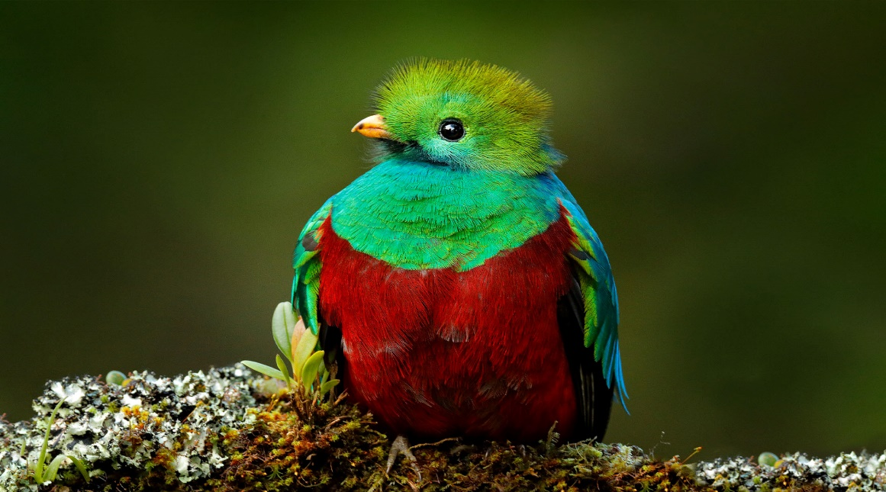

**Costa Rica**

**2024**

**BEAUTIES OF Costa Rica**

**10 days / 9 nights**

2 nights in San José, 2 in Sarapiquí, 2 in San Gerardo de Dota and 3 in Playa Uvita

**DAY 1. San José**

Arrival at **Juan Santamaría International Airport in San José**. Rental car pick up. Free time. Accommodation.

**Day 2. San José - Sarapiquí (88 km)**

**Breakfast**. On this day we will be heading to **Sarapiquí** a place very well known by locals for its rich and breathtaking wildlife. Free rest of the day. Accommodation.

**Day 3. Sarapiquí**

**Breakfast**. Free day to explore around **Sarapiquí**. You can find a couple of natural reserves and national parks such as Braulio Carrillo or La Selva protected zone. Enjoy some outdoor activities such as rafting and hiking. Accommodation.

**Day 4. Sarapiquí – San Gerardo de Dota (170 km)**

**Breakfast**. Early in the morning we will be heading to **San Gerardo de Dota**, famous for being the home of the quetzal bird, one of the most beautiful eye-catching birds. Accommodation.

**DAY 5. SAN GERARDO DE DOTA**

**Breakfast. San Gerardo de Dota** is a place surrounded by natural beauty and spectacular wildlife. During this day you are free to do some fun activities such as bird watching, fishing, hiking or you can simply enjoy the rivers and their incredible waterfalls. Accommodation.

**DAY 6. SAN GERARDO DE DOTA – PLAYA UVITA (117 km)**

**Breakfast**. Our next stop is **Playa Uvita**, located in the Caribbean coast. Here you can find the well-known Marino Ballena National Park, the perfect place to see dolphins and whales. Free rest of the day. Accommodation.

**DAYS 7- 8. PLAYA UVITA**

**Breakfast. Free days** to explore this gorgeous clear water beach. It’s the perfect place to relax and rest. You can also practice some exciting activities such as snorkeling, horseback riding and kayaking. Accommodation.

**DAY 9. PLAYA UVITA – SAN JOSÉ (224 km)**

**Breakfast**. We’re heading back to **San José**. Free time to enjoy the city. We recommend visiting the Plaza de la Cultura, the National Theater, and the Metropolitan Cathedral. Accommodation.

**DAY 10. SAN JOSÉ**

**Breakfast**. Time to head back to San José and return the rental car at the Juan Santamaría International Airport. End of services.

|  |
| --- |
| **STARTING DATES** |

Saturday, Sunday & Monday from January 10TH till December 10th, 2024. Easter time may have add-ons.

|  |
| --- |
| **INCLUDES** |

* Rental car from day 1 - day 10
* 02 nights of accommodation in San José in established hotels or similar
* 02 nights of accommodation in Sarapiquí in established hotels or similar
* 02 nights of accommodation in San Gerardo de Dota in established hotels or similar
* 03 nights of accommodation in Playa Uvita in established hotels or similar
* Daily breakfast
* Local taxes

|  |
| --- |
| **ESTABLISHED HOTELS** |

|  |  |  |
| --- | --- | --- |
| **San José** | Hilton Garden Inn Santa Ana  [www.hilton.com/en/hotels/sjogsgi-hilton-garden-inn-santa-ana-san-jose/](http://www.hilton.com/en/hotels/sjogsgi-hilton-garden-inn-santa-ana-san-jose/) | 2 nights |
| **Sarapiquí** | La Quinta de Sarapiquí  [www.hotellaquintasarapiqui.com](http://www.hotellaquintasarapiqui.com)  Hotel Selva Verde Lodge  [www.selvaverde.com](http://www.selvaverde.com/) | 2 nights |
| **San Gerardo de Dota** | Trogón Lodge  [www.trogonlodge.com](http://www.trogonlodge.com) | 2 nights |
| **Playa Uvita** | Hotel Cristal Ballena  [https://www.cristal-ballena.com](https://www.cristal-ballena.com/es/) | 3 nights |