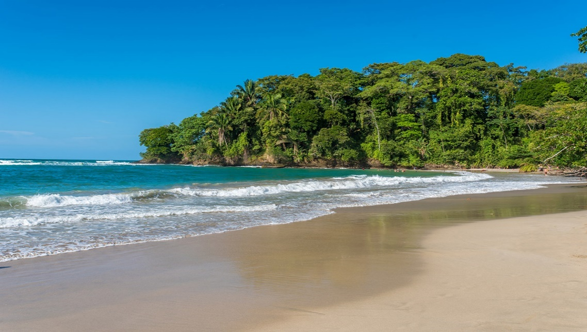

**Costa Rica**

**2024**

**CHARMS of Costa Rica**

**12 days / 11 nights**

2 nights in San José, 2 in Tortuguero, 2 in Arenal, 2 in Monteverde and 3 in Sámara

**Day 1. San José**

Arrival at **Juan Santamaría International Airport** in San José. Shuttle transfer to your hotel. Accommodation.

**Day 2. San José**

**Breakfast**. **Tour to the Volcán Poás National Park and La Paz Waterfall Gardens**. Early in the morning we will be heading to the Poás volcano. On the way there we will be able to admire the Monumento al agricultor, the Juan Santamaría Monument and the famous Parque de los Mangos. Our first stop is at la Casita del Café or Coffee House. The tour guides will give us a brief explanation about the history of coffee. Lots of nature and a fascinating cloud forest will welcome you as we arrive to the first main destination; the Volcán Poás National Park. We will be able to admire the volcano’s active crater as well as its incredible fumaroles. Later that day we will be headed to La Paz Waterfall Garden, a natural park and a wildlife refuge. We are gonna visit breathtaking waterfalls, a butterfly and hummingbird garden and a feline rescue center. Free rest of the day. Accommodation.

**Day 3. San José – Tortuguero (122 km)**

**Full board.** Early in the morning you will be heading to the **Tortuguero** National Park. Once you arrive to port La Pavona, a boat will take you through the famous canals and to your hotel. During the evening you can visit the town of Tortuguero and some of the beaches located nearby. (Breakfast, lunch and dinner are included). Accommodation.

**Day 4. Tortuguero**

**Breakfast**. Free time in the morning. Later in the afternoon you can enjoy the hotel’s private hiking trails and a thrilling boat ride through the **Tortuguero canals** where you will be able to admire the flora and fauna of this magical place. (Breakfast, lunch & dinner are included). Accommodation.

**Day 5. Tortuguero - Arenal (220 km)**

**Breakfast**. On this day a boat is going to take you back to port La Pavona. Then you will be headed to **Arenal**, famous for its majestic 5300 feet tall volcano, hot springs and natural pools. Free rest of the day to relax and explore around the area. Accommodation.

**Day 6. Arenal**

**Breakfast**. **Guided hike to the Arenal Volcano and full access to the Paradise Hot Springs complex**. Explore the amazing trails and walk through the regenerated forest area. You can find a great variety of plants, wildlife, and magnificent rock formations. Later in the day, enjoy the pure mineral water from the interior of the earth, at the hot springs. Accommodation.

**Day 7. Arenal – Monteverde (119 km)**

**Breakfast**. Early in the morning you will be headed to the city of **Monteverde**, located in the northwestern mountainous zone of Costa Rica. Best known for its unique and attractive forest and for being the home to thousands of wildlife species. Upon arrival, you will have free time to explore and walk around. Accommodation.

**Day 8. Monteverde**

**Breakfast**. **Guided hike** through the natural trails and the incredible suspension bridges located all along the dense forests of Monteverde. Free rest of the day. Accommodation.

**Day 9. Monteverde - Sámara (139 km)**

**Breakfast**. We will be heading to **Sámara**, a small town located in the coast of the Pacific. This place is surrounded by breathtaking beaches and amazing views. Free rest of the day. Accommodation.

**Days 10 - 11. Sámara**

**Breakfast**. Free couple of days to enjoy the wide variety of wildlife. In **Sámara** you can find a stunning coral reef, that will take your breath away.

**Day 12. Sámara – San José (224 km)**

**Breakfast**. Time to head back to San José. Transfer to **Juan Santamaría International Airport**. End of services.

**Optional:** You may complete this circuit in a rental car, starting on day 5 in Tortuguero till day 12. Ask your provider for prices.

|  |
| --- |
| **STARTING DATES** |

Saturday, Sunday & Monday from January 10TH till December 10th 2024. Easter time may have add-ons.

|  |
| --- |
| **INCLUDES** |

* Private arrival transfers to the **Juan Santamaría International Airport**
* Regular departure transfer to the **Juan Santamaría International Airport**
* Regular transfers throughout the entire trip
* 02 nights of accommodation in San José in established hotels or similar
* 02 nights of accommodation in Tortuguero in established hotels or similar
* 02 nights of accommodation in Arenal in established hotels or similar
* 02 nights of accommodation in Monteverde in established hotels or similar
* 03 nights of accommodation in Sámara in established hotels or similar
* Daily breakfast, 4 lunches and 2 dinners
* Trips according to program
* Local taxes

|  |
| --- |
| **ADDITIONAL INFORMATION** |

* The order of the trip may vary.
* Mandatory payment (entry + taxes) is required to access the Tortuguero National Park ($17 per person)
* Regular departure transfer for passengers with flights after 17:00. (If the flight is earlier, availability should be checked. Otherwise, a private transfer must be booked).

|  |
| --- |
| **ESTABLISHED HOTELS** |

|  |  |  |
| --- | --- | --- |
|  | **SUPERIOR TOURIST CATEGORY** |  |
| **San José** | La Sabana Hotel Suites y Apartamentos  [www.hotelandapartmentslasabana.com](http://www.hotelandapartmentslasabana.com) | 2 nights |
| **Tortuguero** | Mawamba Lodge Tortuguero  [www.mawamba.com](http://www.mawamba.com) | 2 nights |
| **Arenal** | Hotel Arenal Paraíso Resort & Spa  [www.hotelmagicmountain.com](http://www.hotelmagicmountain.com) | 2 nights |
| **Monteverde** | Monteverde Country Lodge  [www.monteverdecountrylodge.com](http://www.monteverdecountrylodge.com)  Hotel Cipreses  [www.cipresescr.com](http://www.cipresescr.com/) | 2 nights |
| **Sámara** | Hotel Nammbú  [www.nammbu.com](http://www.nammbu.com) | 3 nights |

|  |  |  |
| --- | --- | --- |
|  | **DELUXE CATEGORY** |  |
| **San José** | Hotel Barceló San José  [www.barcelo.com/es-es/barcelo-san-jose/?utm_source=google&utm_medium=organic&utm_campaign=my_business&utm_content=7290](http://www.barcelo.com/es-es/barcelo-san-jose/?utm_source=google&utm_medium=organic&utm_campaign=my_business&utm_content=7290) | 2 nights |
| **Tortuguero** | Mawamba Lodge Tortuguero  [www.mawamba.com](http://www.mawamba.com) | 2 nights |
| **Arenal** | Hotel Arenal Springs Resort & Spa  [www.hotelarenalspring.com/?lang=es](http://www.hotelarenalspring.com/?lang=es) | 2 nights |
| **Monteverde** | Hotel Poco a Poco  [www.hotelpocoapoco.com](http://www.hotelpocoapoco.com)  El Establo Mountain Hotel  [www.elestablo.com](http://www.elestablo.com) | 2 nights |
| **Sámara** | Hotel Nammbú  [www.nammbu.com](http://www.nammbu.com) | 3 nights |