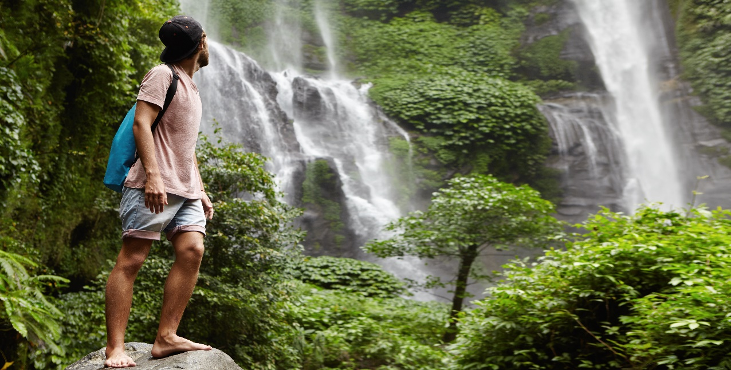

**Costa Rica**

**2024**

**Costa Rica ADVENTURE**

**10 days / 9 nights**

1 night in San José, 2 in Puerto Viejo, 2 in Arenal, 2 in Monteverde and 2 in Jacó

**Day 1. San José**

Arrival at **Juan Santamaría International Airport** in San José. Shuttle transfer to your hotel. Accommodation.

**Day 2. San José - Puerto Viejo (217 km)**

**Breakfast**. Early in the morning you will be headed to **Puerto Viejo**, located in the coast of the Caribbean Sea. It’s the perfect time to enjoy the multiple beaches nearby. We recommend **Playa Negra** or **Punta Uva**. Accommodation.

**Day 3. Puerto Viejo**

**Breakfast**. Prepare to live a once in a lifetime opportunity with the indigenous Bribri community, one of the biggest ethnic groups of the country. You will learn about their unique hunting techniques, the transformation of the cacao seed and about medicinal plants. On the way back to the hotel, we make a stop at the **Dos Aguas Waterfall** for a quick swim. Accommodation.

**DAY 4. PUERTO VIEJO - ARENAL (275 km)**

**Breakfast**. On this day you will be headed to **Arenal**, famous for its majestic 5300 feet tall volcano, hot springs and natural pools. Free rest of the day to relax and explore around the area. Accommodation.

**DAY 5. ARENAL**

**Breakfast**. You will get to enjoy the hiking tour to the wonderful **Río Fortuna Waterfall**, located in the base of the Chato volcano which has been inactive for about 3500 years. Accommodation.

**DAY 6. ARENAL - MONTEVERDE (119 km)**

**Breakfast**. Early in the morning you will be headed to the city of **Monteverde**, located in the northwestern mountainous zone of Costa Rica. It’s best known for its unique and attractive forest and for being the home to thousands of wildlife species. Upon arrival, you will have free time to explore and walk around. Accommodation.

**DAY 7. MONTEVERDE**

**Breakfast**. Enjoy an amazing ziplining experience and submerge yourself in the depths of the **Monteverde forest**. The journey begins with a sky tram that will take you to the highest point of the mountain where you will be able to admire the spectacular and breathtaking views. Then, you will get to complete the canopy circuit that takes you through the forest. Accommodation.

**DAY 8. MONTEVERDE - JACÓ (112 km)**

**Breakfast**. Early in the morning you will be on your way to **Jacó**, a city located in the Pacific coast. It’s considered one of the most developed beach towns in the country. Here you can find a great variety of beaches perfect for surfing, endless nighttime activities and tons of restaurants. Accommodation.

**DAY 9. JACÓ**

**Breakfast**. The day starts with a guided ATV tour, where you will get to explore different trails and rivers. If the climate and the trail conditions allow it, you can take a quick swim in a natural pool that’s nearby. Free time for the rest of the day. Accommodation.

**DAY 10. JACÓ - SAN JOSÉ**

**Breakfast**. A shuttle will take you back to the **Juan Santamaría International Airport**. End of our services.

**Optional:** You may complete this circuit in a rental car, starting on day 1 in San José till day 10. Ask your provider for prices.

|  |
| --- |
| **STARTING DATES** |

Saturday, Sunday & Monday from January 10th till December 10th 2024. Easter time may have add-ons.

|  |
| --- |
| **INCLUDES** |

* Private arrival transfers to the **Juan Santamaría International Airport**
* Regular departure transfer to the **Juan Santamaría International Airport**
* Regular transfers throughout the entire trip
* 01 night of accommodation in San José in established hotels or similar
* 02 nights of accommodation in Puerto Viejo in established hotels or similar
* 02 nights of accommodation in Arenal in established hotels or similar
* 02 nights of accommodation in Monteverde in established hotels or similar
* 02 nights of accommodation in Jacó in established hotels or similar
* Daily breakfast
* Trips according to program:
* Bribri experience in Puerto Viejo
* Hike to Río Fortuna Waterfall in Arenal
* Canopy/ziplining tour in Monteverde
* Quads Adventure tour in Jacó
* Local taxes

|  |
| --- |
| **ADDITIONAL INFORMATION** |

* The order of the trip may vary.
* Regular departure transfer to the Juan Santamaría International Airport for passengers with flights after 17:00. (If the flight is earlier, availability should be checked. Otherwise, a private transfer must be booked.)

|  |
| --- |
| **ESTABLISHED HOTELS** |

|  |  |  |
| --- | --- | --- |
|  | **SUPERIOR TOURIST CATEGORY** |  |
| **San José** | Hotel Auténtico  [www.autenticohotel.com](http://www.autenticohotel.com) | 1 night |
| **Puerto Viejo** | Cariblue Beach & Jungle Resort  [www.cariblue.com](http://www.cariblue.com) | 2 nights |
| **Arenal** | Hotel Magic Mountain  [www.hotelmagicmountain.com](http://www.hotelmagicmountain.com) | 2 nights |
| **Monteverde** | Monteverde Country Lodge  [www.monteverdecountrylodge.com](http://www.monteverdecountrylodge.com)  Hotel Cipreses  [www.cipresescr.com](http://www.cipresescr.com/) | 2 nights |
| **Jacó** | Hotel Terraza del Pacífico  [www.terrazadelpacifico.com](http://www.terrazadelpacifico.com) | 2 nights |

|  |  |  |
| --- | --- | --- |
|  | **DELUXE CATEGORY** |  |
| **San José** | Crowne Plaza Corobicí  [www.ihg.com/crowneplaza/hotels/us/en/san-jose/sjocp/hoteldetail?cm_mmc=GoogleMaps-_-CP-_-CR-_-SJOCP](http://www.ihg.com/crowneplaza/hotels/us/en/san-jose/sjocp/hoteldetail?cm_mmc=GoogleMaps-_-CP-_-CR-_-SJOCP) | 1 night |
| **Puerto Viejo** | Cariblue Beach & Jungle Resort  [www.cariblue.com](http://www.cariblue.com) | 2 nights |
| **Arenal** | Hotel Arenal Springs Resort & Spa  [www.hotelarenalspring.com](http://www.hotelarenalspring.com) | 2 nights |
| **Monteverde** | Hotel Poco a Poco  [www.hotelpocoapoco.com](http://www.hotelpocoapoco.com)  El Establo Mountain Hotel  [www.elestablo.com](http://www.elestablo.com) | 2 nights |
| **Jacó** | Hotel Terraza del Pacífico  [www.terrazadelpacifico.com](http://www.terrazadelpacifico.com) | 2 nights |