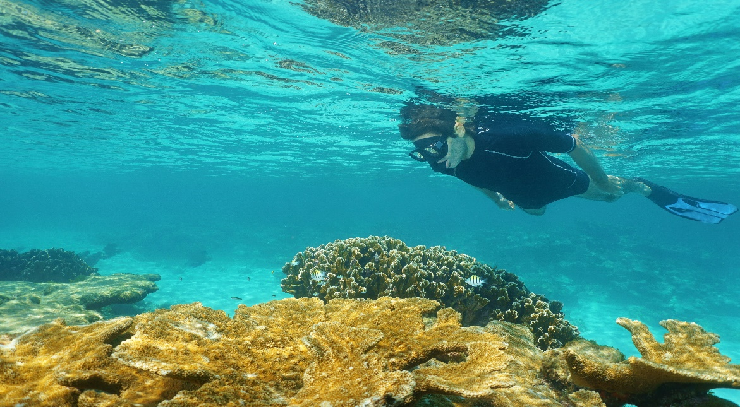

**Costa Rica**

**2024**

**Costa Rica ALL INCLUSIVE**

**09 days / 08 nights**

1 night in San José and 7 in Guanacaste or Jacó

**WITH GUANACASTE**

**DAY 1. SAN JOSÉ**

Arrival at **Juan Santamaría International Airport** in San José. Shuttle transfer to your hotel.

**DAY 2. SAN JOSÉ – GUANACASTE (211 km)**

**Breakfast.** Early in the morning you will be headed to Guanacaste, a tropical paradise with incredible beaches and biodiversity. Arrival, free time and accommodation.

**DAY 3. GUANACASTE**

**All-inclusive accommodation.** Your unforgettable vacations will take place in the breathtaking province of **Guanacaste**, located in the northwest side of the country. Free day to walk around and relax. Accommodation.

**DAY 4. GUANACASTE**

**All-inclusive accommodation.** Enjoy the great amenities your all-inclusive resort offers. Lay back and relax near the pool or with a cocktail by the beach. Accommodation.

**DAY 5. GUANACASTE**

**All-inclusive accommodation.** Relax under the sun in one of the many spectacular beaches nearby. **Guanacaste** has great waves, so you can take some surfing classes or practice an exhilarating aquatic sport. Accommodation.

**DAY 6. GUANACASTE**

**All-inclusive accommodation.** We recommend the one-day excursions to some of the most visited national parks that are located nearby such as **Santa Rosa, Rincón de la Vieja or Palo Verde**. Accommodation.

**DAY 7. GUANACASTE**

**All-inclusive accommodation.** Explore some of the most famous beaches in Guanacaste such as **Tamarindo, Conchal or Flamingo**. Rent some snorkel equipment and dive into an adventure where you will be able to see the extraordinary and beautiful marine life. Accommodation.

**DAY 8. GUANACASTE**

**All-inclusive accommodation.** Enjoy your last day in paradise! Take a swim in the sea, practice some more aquatic sports or simply relax by the pool. Accommodation.

**DAY 9. GUANACASTE – SAN JOSÉ (211 km)**

**Breakfast**. A shuttle will take you back to the **Juan Santamaría International Airport.** End of our services.

**WITH JACÓ**

**DAY 1. SAN JOSÉ**

Arrival at **Juan Santamaría International Airport** in San José. Shuttle transfer to your hotel.

**DAY 2. SAN JOSÉ – JACÓ (85 km)**

**Breakfast.** Early in the morning you will be headed to **Jacó**, a city located on the Pacific coast. Arrival, free time and accommodation.

**DAY 3. JACÓ**

**All-inclusive accommodation.**. **Día libre**. Jacó is considered one of the most developed beach towns in the country. Here you can find a great variety of beaches perfect for surfing, endless nighttime activities and tons of restaurants. Accommodation.

**DAY 4. JACÓ**

**All-inclusive accommodation.** Enjoy the great amenities your all-inclusive resort offers. Lay back and relax near the pool or with a cocktail by the beach. Accommodation.

**DAY 5. JACÓ**

**All-inclusive accommodation.** Relax under the sun in one of the many spectacular beaches nearby. Accommodation

**DAY 6. JACÓ**

**All-inclusive accommodation.**. We recommend the one-day excursions to some of the most visited national parks that are located nearby such as **Santa Rosa Carara.** Accommodation.

**DAY 7. JACÓ**

**All-inclusive accommodation.** Enjoy oceanfront views and a tropical atmosphere! Accommodation.

**DAY 8. JACÓ**

**All-inclusive accommodation.** Enjoy your last day in paradise! Take a swim in the sea, practice some more aquatic sports or simply relax by the pool. Accommodation.

**DAY 9. JACÓ – SAN JOSÉ (85 km)**

**Breakfast**. A shuttle will take you back to the **Juan Santamaría International Airport.** End of our services.

**Optional:** You may complete this circuit in a rental car. Ask your provider for prices.

|  |
| --- |
| **STARTING DATES** |

Saturday, Sunday & Monday from January 10th till December 10th 2024. Easter time may have add-ons.

|  |
| --- |
| **INCLUDES** |

* Private arrival transfers to the **Juan Santamaría International Airport**
* Regular departure transfer to the **Juan Santamaría International Airport**
* Regular transfers throughout the entire trip
* 1 night of accommodation in San José in established hotels or similar
* 7 nights of accommodation in Guanacaste or Jacó in established hotels or similar
* Daily breakfast in San José
* All-inclusive system in the hotel of your choice in Guanacaste or Jacó
* Local taxes

|  |
| --- |
| **ADDITIONAL INFORMATION** |

* Regular departure transfer to the Juan Santamaría International Airport for passengers with flights after 17:00. (If the flight is earlier, availability should be checked. Otherwise, a private transfer must be booked.)

|  |
| --- |
| **ESTABLISHED HOTELS** |

|  |  |  |
| --- | --- | --- |
| **San José** | Crowne Plaza Corobicí  [www.ihg.com/crowneplaza/hotels/us/en/san-jose/sjocp/hoteldetail?cm_mmc=GoogleMaps-_-CP-_-CR-_-SJOCP](http://www.ihg.com/crowneplaza/hotels/us/en/san-jose/sjocp/hoteldetail?cm_mmc=GoogleMaps-_-CP-_-CR-_-SJOCP) | 1 night |
| **Guanacaste** | The Westin Reserva Conchal, an All Inclusive  Golf Resort & Spa  [www.espanol.marriott.com/hotels/travel/lirwi-the-westin-reserva-conchal-an-all-inclusive-golf-resort-and-spa](http://www.espanol.marriott.com/hotels/travel/lirwi-the-westin-reserva-conchal-an-all-inclusive-golf-resort-and-spa) | 7 nights |
| **Guanacaste** | Planet Hollywood Costa Rica, An Autograph Collection All-Inclusive Resort [www.planethollywoodhotels.com/resorts/costa-rica](https://www.planethollywoodhotels.com/resorts/costa-rica) | 7 nights |
| **Jacó** | Best Western Jacó Beach, All Inclusive Resort [www.bestwesternjacobeach.com/es](http://www.bestwesternjacobeach.com/es) | 7 nights |