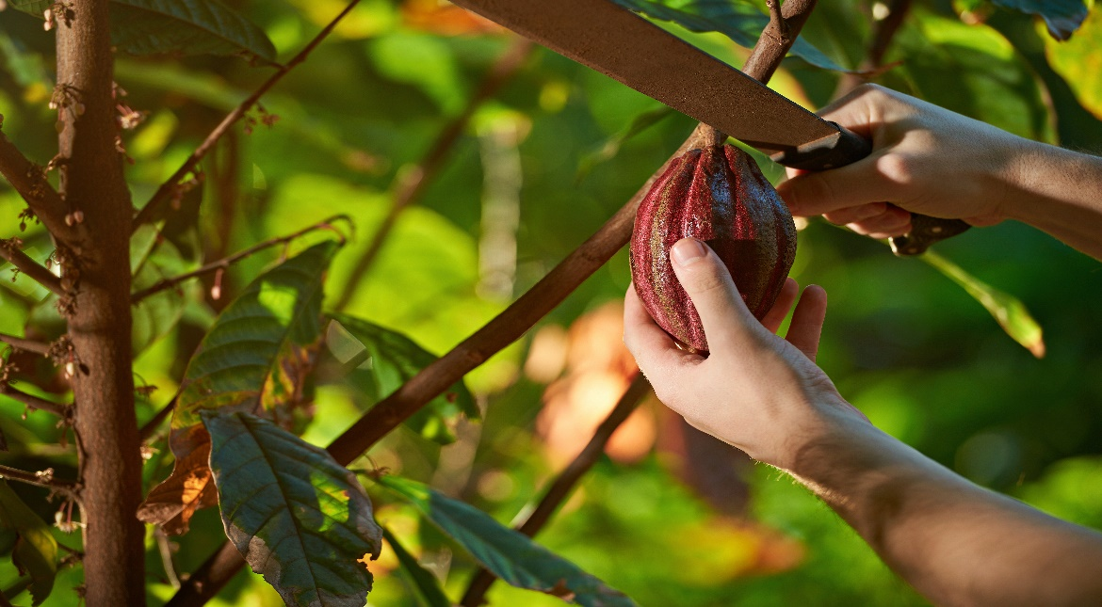

**Costa Rica**

**2024**

**Costa Rica**

**CHOCOLATE,**

**COFFEE & BEACH**

**09 days / 08 nights**

1 night in San José, 2 in Arenal, 2 in Monteverde and 3 in Manuel Antonio

**Day 1. San José**

Arrival at **Juan Santamaría International Airport** in San José. Shuttle transfer to your hotel. Accommodation.

**Day 2. San José - Arenal (139 km)**

**Breakfast**. You will be headed to **Arenal**, famous for its majestic 5300 feet tall volcano, hot springs and natural pools. Free rest of the day to relax and explore around the area. Accommodation.

**Day 3. Arenal**

**Breakfast. Cacao plantation tour included**. Enjoy a sweet experience in the tropical forest, where we will discover the millenary secrets of chocolate: from its discovery and use in the tropical regions of America, to its transformation into the product we know and love today. Considered "a gift from the Gods", the cacao tree had a great importance for the Costa Rican culture, not only for the ceremonial use but also for its economic value. The seeds were used as currency in many regions of Central America, including Costa Rica. You will actively participate in the entire production process, from working at the plantation, harvesting the fruit, drying and grinding the seed to making the traditional drink of our ancestors, and of course tasting organic chocolate of the highest quality. Enjoy this journey through history, culture, traditions, and flavors designed for all ages. Free rest of the day. Accommodation.

**Day 4. Arenal - Monteverde (119 km)**

**Breakfast**. Early in the morning you will be headed to **Monteverde**, located in the northwestern mountainous zone of Costa Rica. It’s best known for its unique and attractive forest and for being the home to thousands of wildlife species. Upon arrival, you will have free time to explore and walk around. Accommodation.

**Day 5. Monteverde**

**Breakfast**. Submerge yourself in the depths of the Monteverde forest and admire nature from a different perspective. Our guide will explain all about the intriguing wildlife that lives within this spectacular place. Our main tour is divided into 3 sections. The **coffee tour**, where we will learn about the wonderful history of this product, as well as its importance in the development of Costa Rica. The **chocolate tour** where we will participate in the entire chocolate process and enjoy the delicious final product. And lastly a tour to a sugar cane mill. Here we will learn about the origin and intricate process to produce this product. The night ends with a hike through the forest trails, where we will try to find different types of animals such as sloths and frogs. Accommodation.

**Day 6. Monteverde - Manuel Antonio (185 km)**

**Breakfast**. On this day you will be heading to **Manuel Antonio**, located in the Pacific Coast of Costa Rica. A place where the forest and the beach come together in one place. Accommodation.

**Days 7 - 8. Manuel Antonio**

**Breakfast**. During this day, you can explore the spectacular nearby beaches, go for a hike, or visit the **Manuel Antonio National Park**, well known for its rich biodiversity, giant humid forest, white sand beaches and breathtaking coral reefs. Accommodation.

**Día 9. Manuel Antonio - San José (155 km)**

Breakfast. A shuttle will take you back to the J**uan Santamaría International Airport**. End of our services.

|  |
| --- |
| **STARTING DATES** |

Saturday, Sunday & Monday from January 10th till December 10th 2024. Easter time may have add-ons.

|  |
| --- |
| **INCLUDES** |

* Private arrival transfers to the **Juan Santamaría International Airport**
* Regular departure transfer to the **Juan Santamaría International Airport**
* Regular transfers throughout the entire trip
* 01 nights of accommodation in San José in established hotels or similar
* 02 nights of accommodation in Arenal in established hotels or similar
* 02 nights of accommodation in Monteverde in established hotels or similar
* 03 nights of accommodation in Manuel Antonio in established hotels or similar
* Daily breakfast
* Trips according to program
* Cacao plantation tour
* Hanging Bridges guided tour
* Night tour in Monteverde
* Local Taxes

|  |
| --- |
| **ADDITIONAL INFORMATION** |

* The order of the trip may vary.
* Regular departure transfer for passengers with flights after 17:00. (If the flight is earlier, availability should be checked. Otherwise, a private transfer must be booked).

|  |
| --- |
| **ESTABLISHED HOTELS** |

|  |  |  |
| --- | --- | --- |
| **San José** | Wyndham Garden Escazú  [www.wyndhamhotels.com/es-xl/wyndham-garden/san-jose-costa-rica/wyndham-garden-san-jose-escazu/overview?CID=LC:46q62bu8edfbx3y:36611](http://www.wyndhamhotels.com/es-xl/wyndham-garden/san-jose-costa-rica/wyndham-garden-san-jose-escazu/overview?CID=LC:46q62bu8edfbx3y:36611) | 1 night |
| **Arenal** | Magic Mountain SPA & Conference Center  [www.hotelmagicmountain.com](http://www.hotelmagicmountain.com) | 2 nights |
| **Monteverde** | Hotel Poco a Poco  [www.hotelpocoapoco.com](http://www.hotelpocoapoco.com)  El Establo Mountain Hotel  [www.elestablo.com](http://www.elestablo.com) | 2 nights |
| **Manuel Antonio** | Karahé Beach Hotel  [www.karahe.com](http://www.karahe.com) | 3 nights |