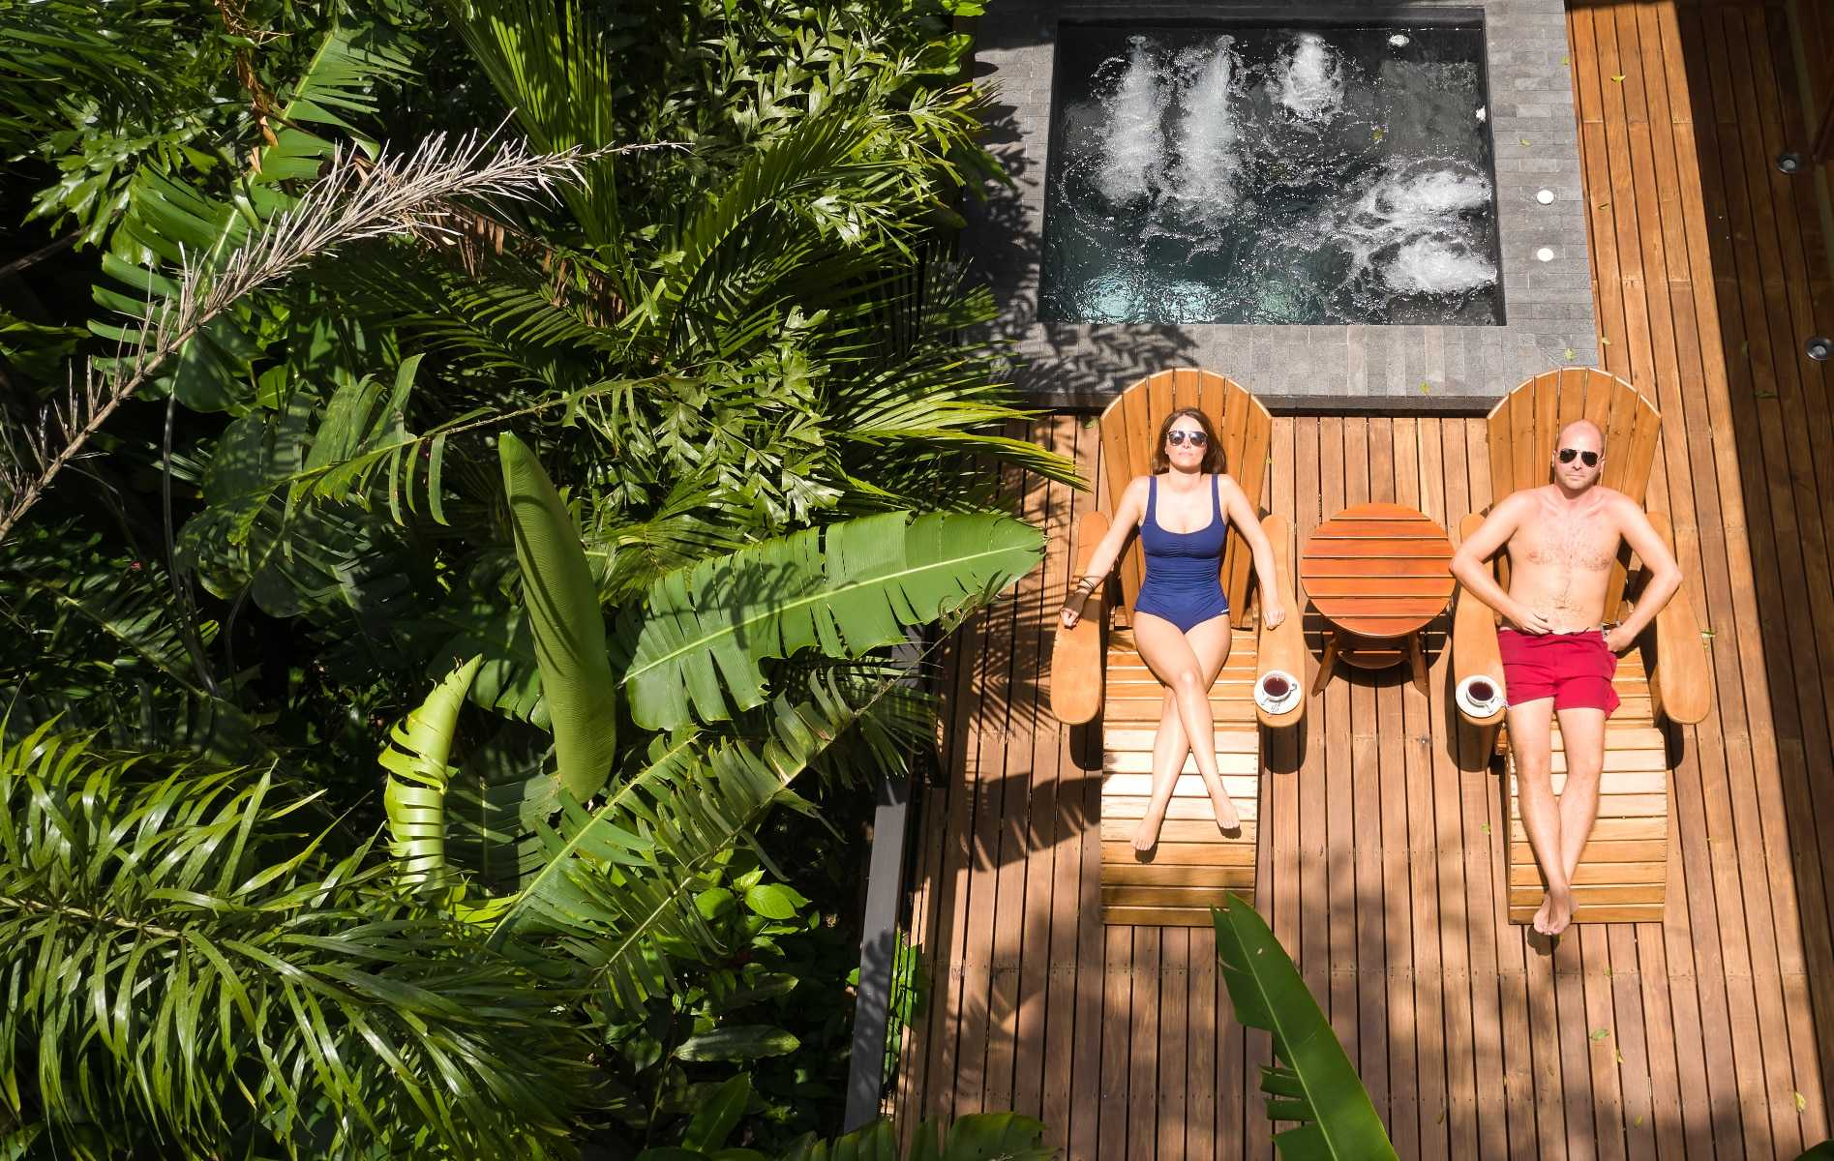

**Costa Rica**

**2024**

**Costa Rica DELUXE**

**11 days / 10 nights**

1 night in San José, 2 in Tortuguero, 2 in Puerto Viejo, 2 in Arenal and 3 in Manuel Antonio

**Day 1. San José**

Arrival at **Juan Santamaría International Airport** in San José. Rental car pick up at the counters located inside the airport. Accommodation.

**Day 2. San José - Tortuguero (122 km)**

**Breakfast**. Early in the morning you will be heading to the **Tortuguero National Park**. Once you arrive to port **La Pavona**, you may park the car there and catch the boat that will take you through the famous canals and to your hotel. During the evening you can visit the town of **Tortuguero** and some of the beaches located nearby. (Breakfast, lunch & dinner are included). Accommodation.

**Day 3. Tortuguero**

**Breakfast**. Free time in the morning. Later in the afternoon you can enjoy the hotel’s private hiking trails and a thrilling boat ride through the **Tortuguero canals** where you will be able to admire the flora and fauna of this magical place. (Breakfast, lunch & dinner are included). Accommodation.

**Day 4. Tortuguero - Puerto Viejo (206 km)**

**Breakfast**. Early in the morning you will be headed to **Puerto Viejo**, located in the coast of the Caribbean Sea. Free time for the rest of the day. Accommodation.

**Day 5. Puerto Viejo**

**Breakfast**. Perfect day to enjoy the multiple beaches located nearby. We recommend **Playa Negra** or **Punta Uva**. We offer an optional indigenous tour with the Bribri community, one of the biggest ethnic groups of the country. On the way back to the hotel we make a stop at the **Dos Aguas Waterfall** for a quick swim. Accommodation.

**Day 6. Puerto Viejo - Arenal (275 km)**

Breakfast. On this day you will be headed to **Arenal**, famous for its majestic 5300 feet tall volcano, hot springs and natural pools. Free rest of the day to relax and explore around the area. Accommodation.

**Day 7. Arenal**

**Breakfast**. Lay back and enjoy the hot springs, waterfalls and natural pools. During the evening, you can take some of the optional tours to the hanging bridges or a trip to the **La Fortuna waterfall**. Accommodation.

**Day 8. Arenal - Manuel Antonio (247 km)**

**Breakfast**. On this day you will be heading to **Manuel Antonio**, located in the Pacific Coast of Costa Rica. A place where the forest and the beach come together in one place. Accommodation.

**Days 9 and 10. Manuel Antonio**

**Breakfast**. Free days to explore the spectacular nearby beaches, go for a hike, or visit the **Manuel Antonio National Park**, well known for its rich biodiversity, giant humid forest, white sand beaches and breathtaking coral reefs. Accommodation.

**Day 11. Manuel Antonio - San José (155 km)**

**Breakfast**. Time to head back to San José and return the rental car at the **Juan Santamaría International Airport**. End of services.

|  |
| --- |
| **STARTING DATES** |

Saturday, Sunday & Monday from January 10TH till December 10th 2024. Easter time may have add-ons.

|  |
| --- |
| **INCLUDES** |

* A rental car for the entire trip
* 01 nights of accommodation in San José in established hotels or similar
* 02 nights of accommodation in Tortuguero in established hotels or similar
* 02 nights of accommodation in Puerto Viejo in established hotels or similar
* 02 nights of accommodation in Arenal in established hotels or similar
* 03 nights of accommodation in Manuel Antonio in established hotels or similar
* Daily breakfast, 2 lunches and 2 dinners
* Trips according to program
* Local taxes

|  |
| --- |
| **ADDITIONAL INFORMATION** |

* The order of the trip may vary.
* Mandatory payment (entry + taxes) is required to access the Tortuguero National Park

($17 per person)

* Price doesn’t include the parking fee in Tortuguero. (It must be paid directly at the National Park)

|  |
| --- |
| **ESTABLISHED HOTELS** |

|  |  |  |
| --- | --- | --- |
| **San José** | Hotel Barceló San José  https://www.barcelo.com/en-ww/barcelo-san-jose.html | 1 night |
| **Tortuguero** | Hotel Manatus  [www.manatuscostarica.com](http://www.manatuscostarica.com) | 2 nights |
| **Puerto Viejo** | Le Cameleon Boutique Hotel  [www.lecameleonhotel.com](http://www.lecameleonhotel.com) | 2 nights |
| **Arenal** | Hotel Amor Arenal  [www.amorarenal.com](http://www.amorarenal.com) | 2 nights |
| **Manuel Antonio** | Los Altos Resort  [www.losaltosresort.com](http://www.losaltosresort.com) | 3 nights |