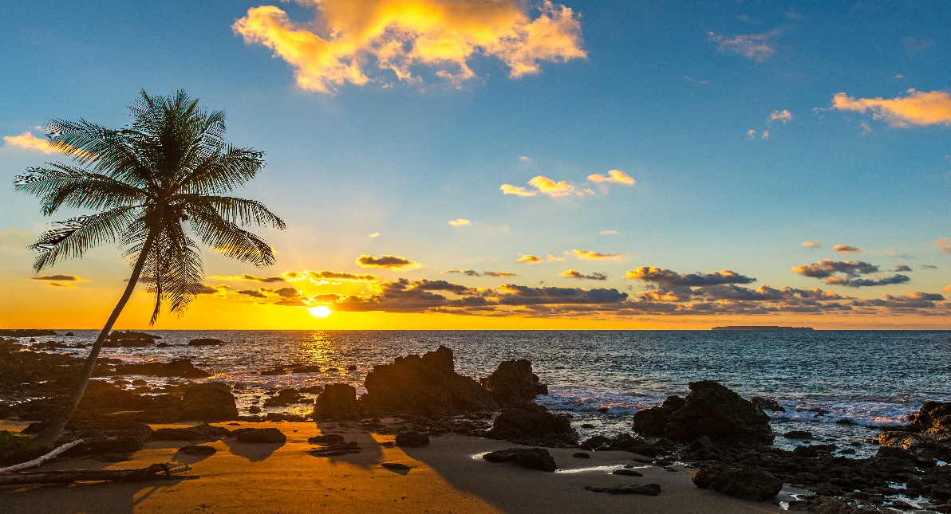

**Costa Rica**

**2024**

**Costa Rica DISTINCT**

**10 days / 09 nights**

2 nights in San José, 3 in Corcovado, 2 in Tortuguero and 2 in Arenal

**Day 1. San José**

Arrival at **Juan Santamaría International Airport** in San José. Shuttle transfer to your hotel. Accommodation.

**Day 2. San José - Corcovado (188 km)**

**Travel by plane**

On this day you will be taking a flight to the remote but magical **Drake Bay**, located in the northern part of the Península de Osa. Upon arrival, a shuttle will take you to the hotel located in **Corcovado**. The rest of the day is free. (Breakfast, lunch & dinner are included). Accommodation.

**Days 3 and 4. Parque Nacional Corcovado**

Free couple of days to go on an adventure and live a wild experience in the breathtaking **Corcovado National Park**. This spectacular place encompasses the only remaining old growth wet forests on the Pacific Coast of Central America. It also possesses an exuberant amount of wildlife. (Breakfast, lunch and dinner are included). Accommodation.

**Day 5. Corcovado National Park - San José (188 km)**

**Travel by plane**

**Breakfast**. At the agreed time, you will be heading back to the airport to catch a flight back to **San José.** Upon arrival, your shuttle will be waiting to take you to your hotel. The rest of the day is free, you may explore the city and everything it has to offer. Accommodation.

**Day 6. San José - Tortuguero (122 km)**

Early in the morning you will be heading to the **Tortuguero National Park**. Once you arrive to port La Pavona, a boat will take you through the famous canals and to your hotel. During the evening you can visit the town of **Tortuguero** and some of the beaches located nearby. (Breakfast, lunch and dinner are included). Accommodation.

**Day 7. Tortuguero**

Free time in the morning. Later in the afternoon you can enjoy the hotel’s private hiking trails and a thrilling boat ride through the **Tortuguero canals** where you will be able to admire the flora and fauna of this magical place. (Breakfast, lunch & dinner are included). Accommodation.

**Day 8. Tortuguero - Arenal (220 km)**

**Breakfast**. On this day a boat is going to take you back to port **La Pavona**. Then you will be headed to **Arenal**, famous for its majestic 5300 feet tall volcano, hot springs and natural pools. Free rest of the day to relax and explore around the area. Accommodation.

**Day 9. Arenal**

**Breakfast**. Lay back and enjoy the hot springs, waterfalls, and natural pools. During the evening, you can take some of the optional tours to the hanging bridges or a trip to the **La Fortuna waterfall**. Accommodation.

**Day 10. Arenal - San José (139 km)**

**Breakfast**. A shuttle will take you back to the **Juan Santamaría International Airport**. End of our services.

|  |
| --- |
| **STARTING DATES** |

Saturday, Sunday & Monday from January 10th till December 10th 2024. Easter time may have add-ons.

|  |
| --- |
| **INCLUDES** |

* Private arrival transfers to the **Juan Santamaría International Airport**
* Regular departure transfer to the **Juan Santamaría International Airport**
* Regular transfers throughout the entire trip
* 02 nights of accommodation in San José in established hotels or similar
* 03 nights of accommodation in Corcovado in established hotels or similar
* 02 nights of accommodation in Tortuguero in established hotels or similar
* 02 nights of accommodation in Arenal in established hotels or similar
* Daily breakfast, 6 lunches and 5 dinners
* Trips according to program
* Local taxes
* Flight San José – Bahía Drake – San José (transfers included)

|  |
| --- |
| **ADDITIONAL NOTES** |

* The order of the trip may vary.
* Mandatory payment (entry + taxes) is required to access the Tortuguero National Park ($17 per person)
* Regular departure transfer for passengers with flights after 20:00. (If the flight is earlier, availability should be checked. Otherwise, a private transfer must be booked.)

|  |
| --- |
| **ESTABLISHED HOTELS** |

|  |  |  |
| --- | --- | --- |
| **San José** | Hilton Garden Inn Santa Ana  [www.hilton.com/en/hotels/sjogsgi-hilton-garden-inn-santa-ana-san-jose/?SEO_id=GMB-AMER-GI-SJOGSGI&y_source=1_MTg5NTI3NzAtNzE1LWxvY2F0aW9uLndlYnNpdGU%3D](https://www.hilton.com/en/hotels/sjogsgi-hilton-garden-inn-santa-ana-san-jose/?SEO_id=GMB-AMER-GI-SJOGSGI&y_source=1_MTg5NTI3NzAtNzE1LWxvY2F0aW9uLndlYnNpdGU%3D) | 2 nights |
| **Corcovado** | Hotel Poor Man´s Paradise  [www.poormansparadisecr.com/es/index.html](https://www.poormansparadisecr.com/es/index.html) | 3 nights |
| **Tortuguero** | Mawamba Lodge Tortuguero  [www.mawamba.com](http://www.mawamba.com) | 2 nights |
| **Arenal** | Hotel Montaña de Fuego Resort & Spa  [www.montanadefuego.com/es/](http://www.montanadefuego.com/es/) | 2 nights |