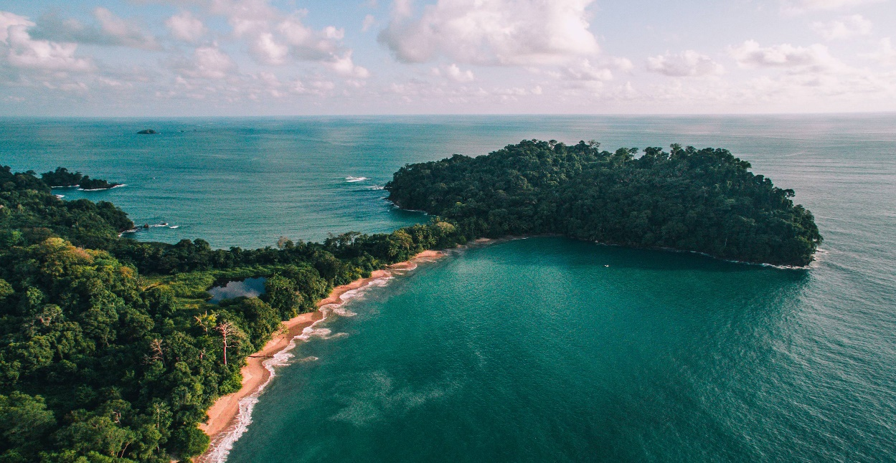

**Costa Rica**

**2024**

**Costa Rica EXPRESS**

**08 days / 07 nights**

1 night in San José, 2 in Arenal, 2 in Monteverde

and 2 in Manuel Antonio

**Day 1. San José**

Arrival at **Juan Santamaría International Airport** in San José. Shuttle transfer to your hotel. Accommodation.

**Día 2. San José - Arenal (139 km)**

**Breakfast**. You will be headed to **Arenal**, famous for its majestic 5300 feet tall volcano, hot springs and natural pools. Free rest of the day to relax and explore around the area. Accommodation.

**Día 3. Arenal**

**Breakfast**. Lay back and enjoy the hot springs, waterfalls and natural pools. During the evening, you can take some of the optional tours to the hanging bridges or a trip to the **La Fortuna waterfall.** Accommodation.

**Día 4. Arenal - Monteverde (119 km)**

**Breakfast**. Early in the morning you will be headed to **Monteverde**, located in the northwestern mountainous zone of Costa Rica. It’s best known for its unique and attractive forest and for being the home to thousands of wildlife species. Upon arrival, you will have free time to explore and walk around. Accommodation.

**Día 5. Monteverde**

**Breakfast**. Spend the whole day exploring the magical and luscious **Monteverde forest**. If you are into adventure and excitement, don’t miss the optional ziplining tour that takes you through the forest canopy. This place also offers great hiking trails and amazing hanging bridges that give you the best view of the place. Accommodation.

**Día 6. Monteverde - Manuel Antonio (185 km)**

**Breakfast**. On this day you will be heading to **Manuel Antonio**, located in the Pacific Coast of Costa Rica. A place where the forest and the beach come together in one place. Accommodation.

**Día 7. Manuel Antonio**

**Breakfast**. During this day, you can explore the spectacular nearby beaches, go for a hike, or visit the **Manuel Antonio National Park**, well known for its rich biodiversity, giant humid forest, white sand beaches and breathtaking coral reefs. Accommodation.

**Día 8. Manuel Antonio - San José (155 km)**

**Breakfast**. A shuttle will take you back to the J**uan Santamaría International Airport**. End of our services.

**Optional:** You may complete this circuit in a rental car, starting on day 1 in San José till day 8. Ask your provider for prices.

|  |
| --- |
| **STARTING DATES** |

Saturday, Sunday & Monday from January 10th till December 10th 2024. Easter time may have add-ons.

|  |
| --- |
| **INCLUDES** |

* Private arrival transfers to the **Juan Santamaría International Airport**
* Regular departure transfer to the **Juan Santamaría International Airport**
* Regular transfers throughout the entire trip
* 01 night of accommodation in San José in established hotels or similar
* 02 nights of accommodation in Arenal in established hotels or similar
* 02 nights of accommodation in Monteverde in established hotels or similar
* 02 nights of accommodation in Manuel Antonio in established hotels or similar
* Daily breakfast
* Trips according to program
* Local Taxes

|  |
| --- |
| **ADDITIONAL INFORMATION** |

* Regular departure transfer for passengers with flights after 17:00. (If the flight is earlier, availability should be checked. Otherwise, a private transfer must be booked).

|  |
| --- |
| **ESTABLISHED HOTELS** |

|  |  |  |
| --- | --- | --- |
|  | **SUPERIOR TOURIST CATEGORY** |  |
| **San José** | Wyndham Garden Escazú  [www.wyndhamhotels.com/es-xl/wyndham-garden/san-jose-costa-rica/wyndham-garden-san-jose-escazu/overview?CID=LC:46q62bu8edfbx3y:36611](http://www.wyndhamhotels.com/es-xl/wyndham-garden/san-jose-costa-rica/wyndham-garden-san-jose-escazu/overview?CID=LC:46q62bu8edfbx3y:36611) | 1 night |
| **Arenal** | Magic Mountain SPA & Conference Center  [www.hotelmagicmountain.com](http://www.hotelmagicmountain.com) | 2 nights |
| **Monteverde** | Monteverde Country Lodge  [www.monteverdecountrylodge.com](http://www.monteverdecountrylodge.com)  Hotel Cipreses  [www.cipresescr.com](http://www.cipresescr.com/) | 2 nights |
| **Manuel Antonio** | Hotel Plaza Yara  [www.hotelyara.com](http://www.hotelyara.com) | 2 nights |

|  |  |  |
| --- | --- | --- |
|  | **DELUXE CATEGORY** |  |
| **San José** | Crowne Plaza Corobicí  [www.ihg.com/crowneplaza/hotels/us/en/san-jose/sjocp/hoteldetail?cm_mmc=GoogleMaps-_-CP-_-CR-_-SJOCP](http://www.ihg.com/crowneplaza/hotels/us/en/san-jose/sjocp/hoteldetail?cm_mmc=GoogleMaps-_-CP-_-CR-_-SJOCP) | 1 night |
| **Arenal** | Hotel Arenal Springs Resort & Spa  [www.hotelarenalspring.com](http://www.hotelarenalspring.com) | 2 nights |
| **Monteverde** | Hotel Poco a Poco  [www.hotelpocoapoco.com](http://www.hotelpocoapoco.com)  El Establo Mountain Hotel  [www.elestablo.com](http://www.elestablo.com) | 2 nights |
| **Manuel Antonio** | Hotel San Bada  [www.hotelsanbada.com](http://www.hotelsanbada.com) | 2 nights |