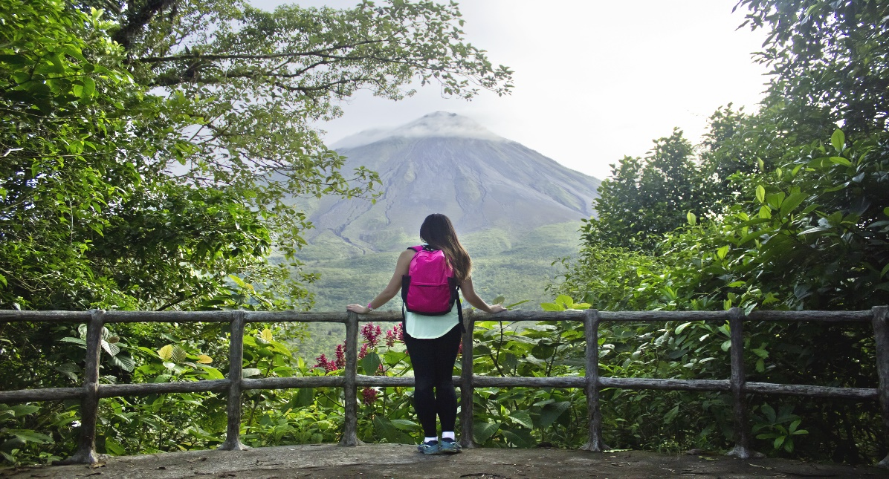

**Costa Rica**

**2024**

**Costa Rica**

**FROM THE CARIBBEAN**

**TO THE PACIFIC**

**12 days / 11 nights**

1 night in San José, 2 in Tortuguero, 2 in Puerto Viejo

2 in Arenal, 2 in Monteverde and 2 in Guanacaste

**Day 1. San José**

Arrival at **Juan Santamaría International Airport** in San José. Shuttle transfer to your hotel. Accommodation.

**Day 2. San José - Tortuguero (122 km)**

Early in the morning you will be heading to the **Tortuguero National Park**. Once you arrive to port **La Pavona**, a boat will take you through the famous canals and then to your hotel. During the evening you can visit the town of **Tortuguero** and some of its beaches. (Breakfast, lunch & dinner are included). Accommodation.

**Day 3. Tortuguero**

Free time in the morning. Later in the afternoon you can enjoy the hotel’s private hiking trails and a thrilling boat ride through the **Tortuguero** canals where you will be able to admire the flora and fauna of this magical place. (Breakfast, lunch & dinner are included). Accommodation.

**Day 4. Tortuguero - Puerto Viejo (206 km)**

**Breakfast**. Early in the morning you will be headed to **Puerto Viejo**, located in the coast of the Caribbean Sea. Free time for the rest of the day. Accommodation.

**Day 5. Puerto Viejo**

**Breakfast**. Great day to enjoy the wonderful beaches nearby, such as **Playa Negra** and **Punta Uva**. We also offer an optional indigenous tour with the Bribri community, one of the biggest ethnic groups of the country. You can also visit the well-known **Cahuita National Park.** Accommodation.

**Day 6. Puerto Viejo - Arenal (275 km)**

**Breakfast**. On this day you will be headed to **Arenal**, famous for its majestic 5300 feet tall volcano, hot springs and natural pools. Free rest of the day to relax and explore around the area. Accommodation.

**Day 7. Arenal**

**Breakfast**. Lay back and enjoy the hot springs, waterfalls and natural pools. During the evening, you can take some of the optional tours to the hanging bridges or a trip to the **La Fortuna waterfall.** Accommodation.

**Day 8. Arenal - Monteverde (119 km)**

**Breakfast**. Early in the morning you will be headed to **Monteverde**, located in the northwestern mountainous zone of Costa Rica. Best known for its unique forest and thousands of wildlife species. Accommodation.

**Day 9. Monteverde**

**Breakfast**. Spend the whole day exploring the magical and luscious **Monteverde forest**. If you are into adventure and excitement, don’t miss the optional ziplining tour that takes you through the forest canopy. Accommodation.

**Day 10. Monteverde - Guanacaste (113 km)**

**Breakfast**. Early in the morning you will be headed to **Guanacaste**, a tropical paradise with incredible beaches and biodiversity. The rest of the day is for you to enjoy the surroundings and relax by the beach. Accommodation.

**Day 11. Guanacaste**

**Breakfast**. Lay under the sun in one of the many spectacular beaches nearby. **Guanacaste** has great waves, so you can also take some surfing classes or practice an aquatic sport. Accommodation.

**Day 12. Guanacaste - San José (211 km)**

**Breakfast**. A shuttle will take you back to the **Juan Santamaría International Airport.** End of our services.

**Optional:** You may complete this circuit in a rental car, starting on day 4 in Tortuguero till day 12. Ask your provider for prices.

|  |
| --- |
| **STARTING DATES** |

Saturday, Sunday & Monday from January 10th till December 10th 2024. Easter time may have add-ons.

|  |
| --- |
| **INCLUDES** |

* Private arrival transfers to the **Juan Santamaría International Airport**
* Regular departure transfer to the **Juan Santamaría International Airport**
* Regular transfers throughout the entire trip
* 01 night of accommodation in San José in established hotels or similar
* 02 nights of accommodation in Tortuguero in established hotels or similar
* 02 nights of accommodation in Puerto Viejo in established hotels or similar
* 02 nights of accommodation in Arenal in established hotels or similar
* 02 nights of accommodation in Monteverde in established hotels or similar
* 02 nights of accommodation in Guanacaste in established hotels or similar
* Daily breakfast, 3 lunches and 2 dinners
* Trips according to program
* Local taxes

|  |
| --- |
| **ADDITIONAL INFORMATION** |

* The order of the trip may vary.
* Mandatory payment (entry + taxes) is required to access the Tortuguero National Park ($17 per person)
* Regular departure transfer for passengers with flights after 17:00. (If the flight is earlier, availability should be checked. Otherwise, a private transfer must be booked.)

|  |
| --- |
| **ESTABLISHED HOTELS** |

|  |  |  |
| --- | --- | --- |
|  | **SUPERIOR TOURIST CATEGORY** |  |
| **San José** | Auténtico Hotel  [www.autenticohotel.com](http://www.autenticohotel.com) | 1 night |
| **Tortuguero** | Pachira Lodge Tortuguero  [www.pachiralodge.com](http://www.pachiralodge.com) | 2 nights |
| **Puerto Viejo** | Cariblue Beach & Jungle Resort  [www.cariblue.com](http://www.cariblue.com) | 2 nights |
| **Arenal** | Hotel Arenal Paraíso Resort & Spa  [www.hotelmagicmountain.com](http://www.hotelmagicmountain.com) | 2 nights |
| **Monteverde** | Monteverde Country Lodge  [www.monteverdecountrylodge.com](http://www.monteverdecountrylodge.com)  Hotel Cipreses  [www.cipresescr.com](http://www.cipresescr.com/) | 2 nights |
| **Guanacaste** | Wyndham Tamarindo  [www.wyndhamhotels.com](http://www.wyndhamhotels.com) | 2 nights |

|  |  |  |
| --- | --- | --- |
|  | **DELUXE CATEGORY** |  |
| **San José** | Wyndham Garden Escazú  [www.wyndhamhotels.com/es-xl/wyndham-garden/san-jose-costa-rica/wyndham-garden-san-jose-escazu/overview?CID=LC:46q62bu8edfbx3y:36611](http://www.wyndhamhotels.com/es-xl/wyndham-garden/san-jose-costa-rica/wyndham-garden-san-jose-escazu/overview?CID=LC:46q62bu8edfbx3y:36611) | 1 night |
| **Tortuguero** | Pachira Lodge Tortuguero  [www.pachiralodge.com](http://www.pachiralodge.com) | 2 nights |
| **Puerto Viejo** | Cariblue Beach & Jungle Resort  [www.cariblue.com](http://www.cariblue.com) | 2 nights |
| **Arenal** | Arenal Springs Resort & Spa  [www.hotelarenalspring.com/?lang=es](http://www.hotelarenalspring.com/?lang=es) | 2 nights |
| **Monteverde** | Hotel Poco a Poco  [www.hotelpocoapoco.com](http://www.hotelpocoapoco.com)  El Establo Mountain Hotel  [www.elestablo.com](http://www.elestablo.com) | 2 nights |
| **Guanacaste** | Tamarindo Diria Beach Resort  [www.tamarindodiria.com](http://www.tamarindodiria.com) | 2 nights |