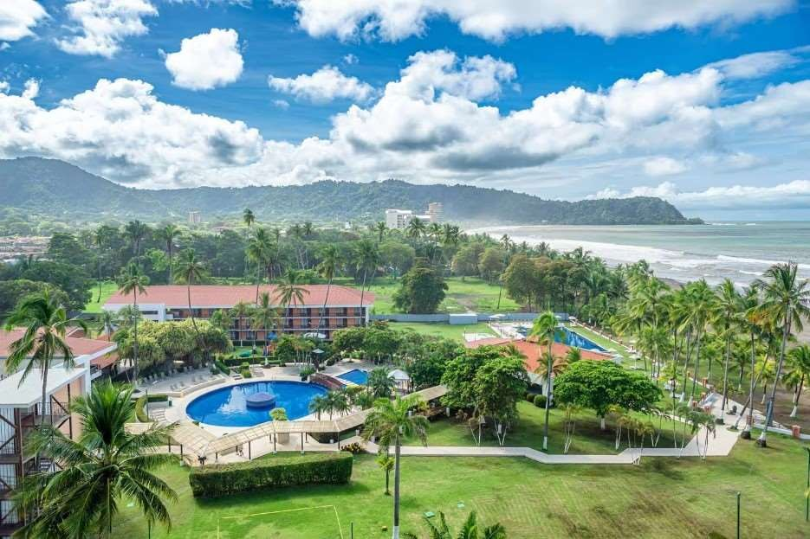

# Costa Rica

**2024**

# Costa Rica PURA VIDA

**9 days / 8 nights**

1 night in San José, 2 in Tortuguero, 2 in Arenal and 3 in Jacó

## Day 1. SAN JOSÉ

Arrival at Juan Santamaría International airport in San José. Shuttle transfer to your hotel. Free time to enjoy the capital of Costa Rica. We recommend visiting the “Plaza de la Cultura”, the National Theater, the Metropolitan Cathedral and the Central Park.

## DAY 2. SAN JOSÉ – TORTUGUERO (122 km)

Early in the morning you will be heading to the Tortuguero National Park. Once you arrive to port La Pavona, a boat will take you through the famous canals and then to your hotel. During the evening you can visit the town of Tortuguero and some of the beaches located nearby. (Breakfast, lunch and dinner are included).

## DAY 3. TORTUGUERO

Free time in the morning. Later in the afternoon you can enjoy the hotel’s private hiking trails and a thrilling boat ride through the Tortuguero canals, where you will be able to admire the flora and fauna of this magical place. (Breakfast, lunch & dinner are included)

## DAY 4. TORTUGUERO – ARENAL (220 km)

Breakfast. On this day, a boat will take you back to port La Pavona. You will be headed to Arenal, famous for its majestic 5300 feet tall volcano, hot springs, and natural pools. Free rest of the day to relax and explore around the area.

## DAY 5. ARENAL

Breakfast. Lay back and enjoy your free day in this majestic place. During the evening, you can take some of the optional tours to the hanging bridges or a trip to the La Fortuna waterfall.

## DAY 6. ARENAL – JACÓ (186 km)

Breakfast. Departure to Jacó, a town located on the Pacific coast, where you can find wonderful beaches, crystal clear waters and magnificent sceneries. Free rest of the day to relax and explore around. Dinner is included.

## DAYS 7 AND 8. JACÓ

Enjoy the amenities your all-inclusive resort has to offer. Enjoy oceanfront views and a tropical atmosphere! Jacó is kvnown for its surfing beaches, variety of restaurants and great nightlife.

## DAY 9. JACÓ – SAN JOSÉ (85 km)

Breakfast. A shuttle will take you back to the Juan Santamaría International Airport. End of our services.

**Optional:** You may complete this circuit from day 4 in Tortuguero till day 8 in a rental car. Ask your provider for prices.

**STARTING DATES**

Saturday, Sunday & Monday from January 10th till December 10th 2024. Easter time may have add-ons.

**PRICE INCLUDES**

* Private arrival transfer
* Regular departure transfer
* Transfers in regular services throughout the entire trip
* 8 nights of accommodation in established hotels or similar
* Daily breakfast
* 3 lunches and 2 dinners in Tortuguero
* All-inclusive resort in Jacó: use of facilities, meals (3 meals and snacks), unlimited national alcoholic beverages (except minors), unlimited soft drinks, recreational activities plan, gratuities and WIFI.
* Trips according to program
* Local Taxes

**ADDITIONAL INFORMATION**

* The order of the trip may vary.
* Mandatory payment (entry + taxes) is required to access the Tortuguero National Park (Around $17 per person)
* Regular departure transfer for passengers with flights after 17:00. (If the flight is earlier, availability should be checked. Otherwise, a private transfer must be booked).

**ESTABLISHED HOTELS**

|  |  |  |
| --- | --- | --- |
| **San José** | Wyndham Garden Escazú [www.wyndhamhotels.com/es-xl/wyndham-](http://www.wyndhamhotels.com/es-xl/wyndham-) garden/san-jose-costa-rica/wyndham-garden-san- jose- escazu/overview?CID=LC:46q62bu8edfbx3y:36611 | 1 night |
| **Tortuguero** | Laguna Lodge Tortuguero [www.lagunatortuguero.com](http://www.lagunatortuguero.com/) | 2 nights |
| **Arenal** | Montaña de Fuego Resort & Spa [www.montanadefuego.com](http://www.montanadefuego.com/) | 2 nights |
| **Jacó** | Best Western Jacó Beach, All Inclusive Resort [www.bestwesternjacobeach.com](http://www.bestwesternjacobeach.com/) | 3 nights |