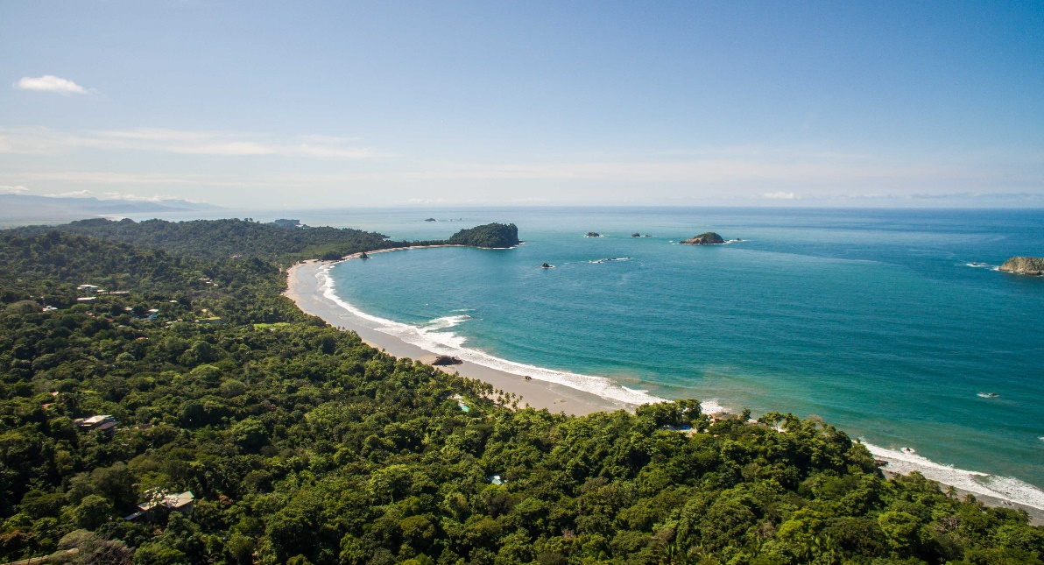


Costa Rica
2024

Costa Rica
WITHOUT A HURRY
12 days / 11 nights
2 nights in San José, 2 in Tortuguero, 2 in Arenal
2 in Monteverde and 3 in Manuel Antonio

Day 1. San José
Arrival at Juan Santamaría International airport in San José. Shuttle transfer to your hotel. Accommodation.

Day 2. San José - Tortuguero (122 km)
Early in the morning you will be heading to the Tortuguero National Park. Once you arrive to port La Pavona, a boat will take you through the famous canals and then to your hotel. During the evening you can visit the town of Tortuguero and some of the beaches located nearby. (Breakfast, lunch and dinner are included). Accommodation.

Day 3. Tortuguero
Free time in the morning. Later in the afternoon you can enjoy the hotel’s private hiking trails and a thrilling boat ride through the Tortuguero Canals where you will be able to admire the flora and fauna of this magical place. (Breakfast, lunch & dinner are included). Accommodation.

Day 4. Tortuguero - Arenal (220 km)
Breakfast. On this day a boat is going to take you back to port La Pavona. You will be headed to Arenal, famous for its majestic 5300 feet tall volcano, hot springs and natural pools. Free rest of the day to relax and explore around the area. Accommodation.

Day 5. Arenal
Breakfast. Lay back and enjoy the hot springs, waterfalls and natural pools. During the evening, you can take some of the optional tours to the hanging bridges or a trip to the La Fortuna waterfall. Accommodation.

Day 6. Arenal - Monteverde (119 km)
Breakfast. Early in the morning you will be headed to the city of Monteverde, located in the northwestern mountainous zone of Costa Rica. Best known for its unique and attractive forest and for being the home to thousands of wildlife species. Upon arrival, you will have free time to explore and walk around. Accommodation.

Day 7. Monteverde
Breakfast. Spend the whole day exploring the magical and luscious Monteverde forest. If you are into adventure and excitement, don’t miss the optional ziplining tour that takes you through the forest canopy. This place also offers great hiking trails and amazing hanging bridges that give you the best view of the place. Accommodation.

Day 8. Monteverde - Manuel Antonio (185 km)
Breakfast. On this day you will be heading to Manuel Antonio, located in the Pacific coast of the country. This place is well known for its dense rainforest and peaceful clear water beaches. Accommodation.

Day 9 and 10. Manuel Antonio
Breakfast. During these days you can explore the spectacular nearby beaches, go for a hike, or visit the Manuel Antonio National Park, well known for its rich biodiversity, giant humid forest, white sand beaches and breathtaking coral reefs. Accommodation.

Day 11. Manuel Antonio - San José (155 km)
Breakfast. Early in the morning a shuttle will take you to San José, the capital of Costa Rica. Upon arrival, you have a free rest of the day, ideal to explore the different tourist attractions such as the National Theater, The Metropolitan Cathedral and the Central Park. Accommodation.

Day 12. San José
Breakfast. A shuttle will take you back to the Juan Santamaría International Airport. End of our services.

Optional: You may complete this circuit in a rental car, starting on day 4 in Tortuguero until day 12. Ask your provider for prices.

STARTING DATES

Saturday, Sunday & Monday from January 10th till December 10th 2024. Easter time may have add-ons.

INCLUDES

- Private arrival transfers to the Juan Santamaría International Airport
- Private departure transfer to the Juan Santamaría International Airport
- Regular transfers throughout the entire trip
- 02 nights of accommodation in San José in established hotels or similar
- 02 nights of accommodation in Tortuguero in established hotels or similar
- 02 nights of accommodation in Arenal in established hotels or similar
- 02 nights of accommodation in Monteverde in established hotels or similar
- 03 nights of accommodation in Manuel Antonio in established hotels or similar
- Daily breakfast, 3 lunches and 2 dinners
- Trips according to program
- Local taxes

ADDITIONAL NOTES

- The order of the trip may vary.
- Mandatory payment (entry + taxes) is required to access the Tortuguero National Park ($17 per person)

ESTABLISHED HOTELS

 | SUPERIOR TOURIST CATEGORY
San José | Hotel Radisson San José  www.choicehotels.com/es-us/costa-rica/san-jose/radisson-hotels/cr025?mc=llgoxxpx | 2 nights
Tortuguero | Laguna Lodge Tortuguero  www.lagunatortuguero.com | 2 nights
Arenal | Montaña de Fuego Resort & Spa  www.montanadefuego.com/es/ | 2 nights
Monteverde | Monteverde Country Lodge  www.monteverdecountrylodge.com  Hotel Cipreses  www.cipresescr.com | 2 nights
Manuel Antonio | Karahé Beach Hotel  www.karahe.com | 3 nights

 | DELUXE CATEGORY
San José | Hilton Garden Inn Santa Ana  www.hilton.com/en/hotels/sjogsgi-hilton-garden-inn-santa-ana-san-jose/ | 2 nights
Tortuguero | Laguna Lodge Tortuguero  www.lagunatortuguero.com | 2 nights
Arenal | Hotel Arenal Springs Resort & Spa  www.hotelarenalspring.com/?lang=es | 2 nights
Monteverde | Hotel Poco a Poco  www.hotelpocoapoco.com  El Establo Mountain Hotel  www.elestablo.com | 2 nights
Manuel Antonio | Hotel San Bada  www.hotelsanbada.com | 3 nights

