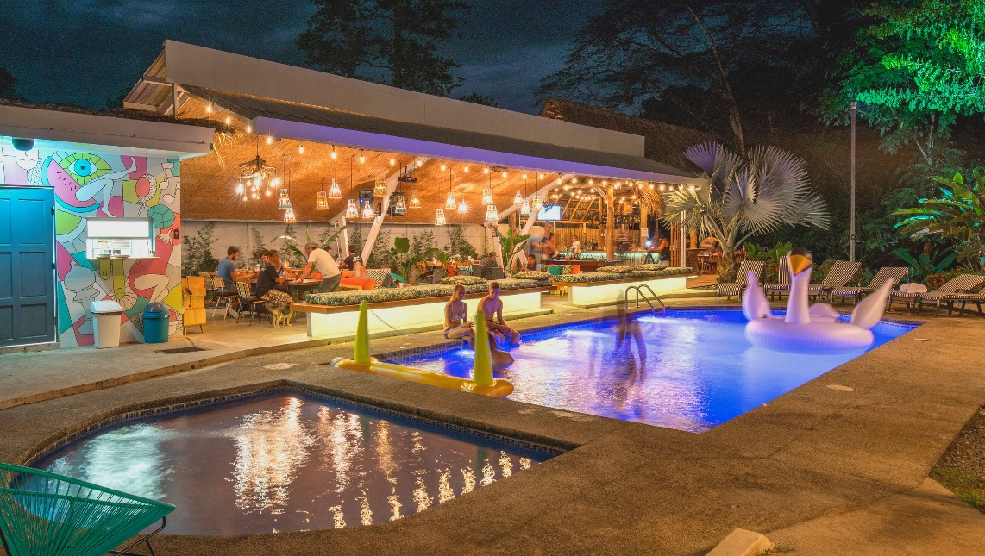

**Costa Rica**

**2024**

**Costa Rica YOUTHFUL**

**BY SELINA HOTELS**

**11 days / 10 nights**

1 night in San José, 3 in Puerto Viejo, 2 in Arenal, 2 in Monteverde and 2 in Manuel Antonio

**Day 1. San José**

Arrival at **Juan Santamaría International Airport** in San José. Shuttle transfer to your hotel. (A welcome drink is included). Accommodation.

**Day 2. San José - Puerto Viejo (217 km)**

**Breakfast**. Early in the morning you will be headed to **Puerto Viejo**, located in the coast of the Caribbean Sea. Upon arrival, you will get a welcome drink and free time for the rest of the day. Accommodation.

**Day 3. Puerto Viejo**

**Breakfast**. Perfect day to enjoy the multiple beaches located nearby. We recommend **Playa Negra** or **Punta Uva**. We offer an optional indigenous tour with the Bribri community, one of the biggest ethnic groups of the country. On the way back to the hotel we make a stop at the **Dos Aguas Waterfall** for a quick swim. Accommodation.

**Day 4. Puerto Viejo**

**Breakfast**. It’s the perfect time to explore the surrounding areas. We offer an optional visit to the **Cahuita National Park**, where you will find hiking trails, white sand beaches with clear turquoise waters. Accommodation.

**Day 5. Puerto Viejo - Arenal (275 km)**

**Breakfast**. You will be headed to **Arenal**, famous for its majestic 5300 feet tall volcano, hot springs and natural pools. It’s one of those places that you wouldn’t want to miss! (Welcome drink included). Accommodation.

**Day 6. Arenal**

**Breakfast**. Lay back and enjoy the hot springs, waterfalls and natural pools. During the evening, you can take some of the optional tours to the hanging bridges or a trip to the **La Fortuna waterfall**. Accommodation.

**Day 7. Arenal - Monteverde (119 km)**

**Breakfast**. Early in the morning you will be headed to the city of **Monteverde**, located in the northwestern mountainous zone of Costa Rica. It’s best known for its unique and attractive forest and for being the home to thousands of wildlife species. Upon arrival, you will have free time to explore and walk around. Accommodation.

**Day 8. Monteverde**

**Breakfast**. Spend the whole day exploring the magical and luscious **Monteverde** forest. If you are into adventure and excitement, don’t miss the optional ziplining tour that takes you through the forest canopy. This place also offers great hiking trails and some amazing hanging bridges. Accommodation.

**Day 9. Monteverde - Manuel Antonio (185 km)**

**Breakfast**. On this day you will be heading to **Manuel Antonio**, located in the Pacific Coast of Costa Rica. A place where the forest and the beach come together in one place. (Welcome drink included) Accommodation.

**Day 10. Manuel Antonio**

**Breakfast**. During these days, you can explore the spectacular nearby beaches, go for a hike, or visit the **Manuel Antonio National Park**, well known for its rich biodiversity, giant humid forest, white sand beaches and breathtaking coral reefs. Accommodation.

**DAY 11. MANUEL ANTONIO - SAN JOSÉ (155 km)**

**Breakfast**. A shuttle will take you back to the **Juan Santamaría International Airport**. End of our services

**Optional:** You may complete this circuit in a rental car, starting on day 1 in San José till day 11. Ask your provider for prices.

|  |
| --- |
| **STARTING DATES** |

Saturday, Sunday & Monday from January 10th till December 10th 2024. Easter time may have add-ons.

|  |
| --- |
| **INCLUDES** |

* Private arrival transfers to the **Juan Santamaría International Airport**
* Regular departure transfer to the **Juan Santamaría International Airport**
* Regular transfers throughout the entire trip
* 01 night of accommodation in San José in established hotels or similar
* 03 nights of accommodation in Puerto Viejo in established hotels or similar
* 02 nights of accommodation in Arenal in established hotels or similar
* 02 nights of accommodation in Monteverde in established hotels or similar
* 02 nights of accommodation in Manuel Antonio in established hotels or similar
* Daily breakfast
* Trips according to program
* Welcome drinks on every hotel
* Access to the hotel facilities
* Free high speed WIFI
* Live music
* Wellness activities and yoga classes
* Movie theater and entertainment
* Local taxes

|  |
| --- |
| **STARTING DATES** |

* Regular departure transfer for passengers with flights after 17:00. (If the flight is earlier, availability should be checked. Otherwise, a private transfer must be booked.)

|  |
| --- |
| **ESTABLISHED HOTELS** |

|  |  |  |
| --- | --- | --- |
| **San José** | Selina San José  [www.selina.com](http://www.selina.com) | 1 night |
| **Puerto Viejo** | Selina Puerto Viejo  [www.selina.com](http://www.selina.com) | 3 nights |
| **Arenal** | Selina La Fortuna  [www.selina.com](http://www.selina.com) | 2 nights |
| **Monteverde** | Selina Monteverde  [www.selina.com](http://www.selina.com/es/) | 2 nights |
| **Jacó** | Selina Jacó  [www.selina.com](http://www.selina.com) | 2 nights |
| **Manuel Antonio** | Selina Manuel Antonio  [www.selina.com](http://www.selina.com) | 2 nights |

**Selina San José**

[**https://www.selina.com/es/costa-rica/san-jose/?camp_data=%7B%22utm_campaign%22%3A%2212046722841%22%2C%20%22utm_source%22%3A%22google%22%2C%20%22utm_medium%22%3A%22cpc%22%2C%20%22utm_content%22%3A%22494645940399%22%7D&gclid=Cj0KCQjwz96WBhC8ARIsAATR253DKFu_9A7vDXZF6TCCgtRu0Rb8ghCxuQTjsFsTB4LRSPxeiA1zOKMaAr5BEALw_wcB**](https://www.selina.com/es/costa-rica/san-jose/?camp_data=%7B%22utm_campaign%22%3A%2212046722841%22%2C%20%22utm_source%22%3A%22google%22%2C%20%22utm_medium%22%3A%22cpc%22%2C%20%22utm_content%22%3A%22494645940399%22%7D&gclid=Cj0KCQjwz96WBhC8ARIsAATR253DKFu_9A7vDXZF6TCCgtRu0Rb8ghCxuQTjsFsTB4LRSPxeiA1zOKMaAr5BEALw_wcB)

**Selina Puerto Viejo**

[**www.selina.com/es/costa-rica/puerto-viejo/?camp_data=%7B%22utm_campaign%22%3A%2212046722841%22%2C%20%22utm_source%22%3A%22google%22%2C%20%22utm_medium%22%3A%22cpc%22%2C%20%22utm_content%22%3A%22494645940384%22%7D&gclid=Cj0KCQjwz96WBhC8ARIsAATR252JOhByg18uuvU2MRvqg9YyzbbaAxk1ORrL3q_jTGhZqiR__VyEfyEaAuSDEALw_wcB**](https://www.selina.com/es/costa-rica/puerto-viejo/?camp_data=%7B%22utm_campaign%22%3A%2212046722841%22%2C%20%22utm_source%22%3A%22google%22%2C%20%22utm_medium%22%3A%22cpc%22%2C%20%22utm_content%22%3A%22494645940384%22%7D&gclid=Cj0KCQjwz96WBhC8ARIsAATR252JOhByg18uuvU2MRvqg9YyzbbaAxk1ORrL3q_jTGhZqiR__VyEfyEaAuSDEALw_wcB)

**Selina La Fortuna**

[**www.selina.com/es/costa-rica/la-fortuna/?camp_data=%7B%22utm_campaign%22%3A%2212046722841%22%2C%20%22utm_source%22%3A%22google%22%2C%20%22utm_medium%22%3A%22cpc%22%2C%20%22utm_content%22%3A%22494645940237%22%7D&gclid=Cj0KCQjwz96WBhC8ARIsAATR2501zMOcmUZjoAJmwHgaTqaLaNFvF655-iufl1FxL2KqxjhajiKEMbUaAqd3EALw_wcB**](http://www.selina.com/es/costa-rica/la-fortuna/?camp_data=%7B%22utm_campaign%22%3A%2212046722841%22%2C%20%22utm_source%22%3A%22google%22%2C%20%22utm_medium%22%3A%22cpc%22%2C%20%22utm_content%22%3A%22494645940237%22%7D&gclid=Cj0KCQjwz96WBhC8ARIsAATR2501zMOcmUZjoAJmwHgaTqaLaNFvF655-iufl1FxL2KqxjhajiKEMbUaAqd3EALw_wcB)

**Selina Monteverde**

[**www.selina.com/es/costa-rica/monteverde/?camp_data=%7B%22utm_campaign%22%3A%2212046722841%22%2C%20%22utm_source%22%3A%22google%22%2C%20%22utm_medium%22%3A%22cpc%22%2C%20%22utm_content%22%3A%22494645940381%22%7D&gclid=Cj0KCQjwz96WBhC8ARIsAATR251RB5JEyHpjuYh1KKGSdBcRN8wPDwT7d1DtTdrn2ITvuLTQSptqc1MaAlVwEALw_wcB**](http://www.selina.com/es/costa-rica/monteverde/?camp_data=%7B%22utm_campaign%22%3A%2212046722841%22%2C%20%22utm_source%22%3A%22google%22%2C%20%22utm_medium%22%3A%22cpc%22%2C%20%22utm_content%22%3A%22494645940381%22%7D&gclid=Cj0KCQjwz96WBhC8ARIsAATR251RB5JEyHpjuYh1KKGSdBcRN8wPDwT7d1DtTdrn2ITvuLTQSptqc1MaAlVwEALw_wcB)

**Selina Manuel Antonio**

[**www.selina.com/es/costa-rica/manuel-antonio/?camp_data=%7B%22utm_campaign%22%3A%2212046722841%22%2C%20%22utm_source%22%3A%22google%22%2C%20%22utm_medium%22%3A%22cpc%22%2C%20%22utm_content%22%3A%22490884662765%22%7D&gclid=Cj0KCQjwz96WBhC8ARIsAATR2522lqCPVdFbiGaQsCsfEdvuA88_xq45I87pO0U_6XcZ5J5GdqOSfSAaApQdEALw_wcB**](http://www.selina.com/es/costa-rica/manuel-antonio/?camp_data=%7B%22utm_campaign%22%3A%2212046722841%22%2C%20%22utm_source%22%3A%22google%22%2C%20%22utm_medium%22%3A%22cpc%22%2C%20%22utm_content%22%3A%22490884662765%22%7D&gclid=Cj0KCQjwz96WBhC8ARIsAATR2522lqCPVdFbiGaQsCsfEdvuA88_xq45I87pO0U_6XcZ5J5GdqOSfSAaApQdEALw_wcB)