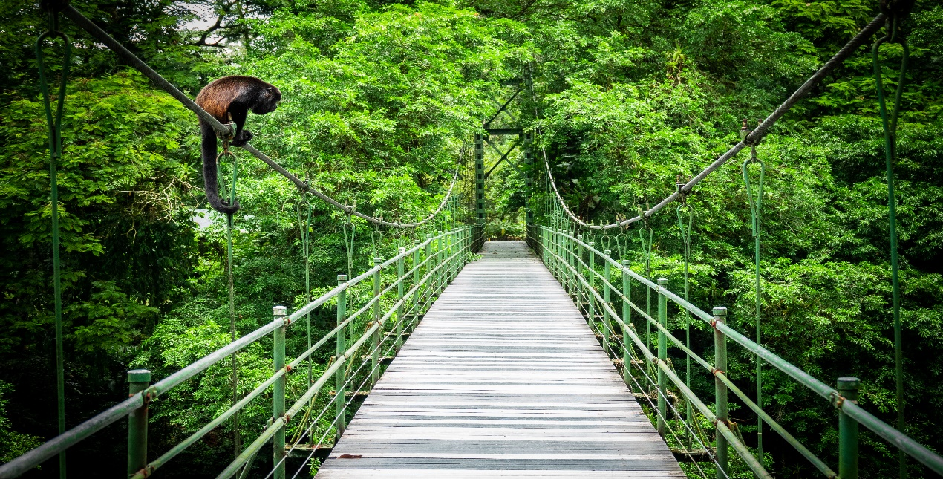

**Costa Rica**

**2024**

**ESSENTIAL Costa Rica**

**13 days / 12 nights**

2 nights in San José, 2 in Tortuguero,

3 in Sarapiquí, 2 in Arenal and 3 in Guanacaste

**Day 1. San José**

Arrival at **Juan Santamaría International Airport in San José**. Shuttle transfer to your hotel. Free time. Accommodation.

**Day 2. San José - Tortuguero (122 km)**

Early in the morning you will be heading to the **Tortuguero National Park**. Once you arrive to port **La Pavona**, you may park the car there and catch the boat that will take you through the famous canals and to your hotel. During the evening you can visit the town of **Tortuguero** and some of the beaches located nearby. (Breakfast, lunch & dinner are included). Accommodation.

**Day 3. Tortuguero**

Free time in the morning. Later in the afternoon you can enjoy the hotel’s private hiking trails and a thrilling boat ride through the **Tortuguero canals** where you will be able to admire the flora and fauna of this magical place. (Breakfast, lunch & dinner are included). Accommodation.

**Day 4. Tortuguero – Sarapiquí (114 km)**

**Breakfast**. Early in the morning you will be headed to Sarapiquí, a place very well known by locals for its rich and breathtaking wildlife. Free rest of the day. Accommodation.

**Days 5 - 6. Sarapiquí**

**Breakfast**. Free days to explore around Sarapiquí. You can find a couple of natural reserves and national parks such as Braulio Carrillo or La Selva protected zone. Enjoy some outdoor activities such as rafting and hiking. Accommodation.

**Day 7. Sarapiquí - Arenal (117 km)**

**Breakfast**. On this day you will be headed to **Arenal**, famous for its majestic 5300 feet tall volcano, hot springs and natural pools. Free rest of the day to relax and explore around the area. Accommodation.

**Day 8. Arenal**

**Breakfast**. Lay back and enjoy the hot springs, waterfalls and natural pools. During the evening, you can take some of the optional tours to the hanging bridges or a trip to th**e La Fortuna waterfall.** Accommodation.

**Day 9. Arenal - Guanacaste (186 km)**

**Breakfast**. Our next stop is Liberia, the largest city in Guanacaste, surrounded by stunning beaches, volcanoes and jungles. Free rest of the day. Accommodation.

**Days 10 - 11. Guanacaste**

**Breakfast**. Free couple of days to discover the wonders of Liberia. You will be able to find some of the best beaches to practice snorkeling and surfing as well as the famous Rincón de la Vieja National Park. Accommodation.

**Day 12. Guanacaste - San José (255 km)**

**Breakfast**. Early in the morning a shuttle will take you to **San José**, the capital of Costa Rica. Upon arrival, you have a free rest of the day, ideal to explore the different tourist attractions such as the National Theater, The Metropolitan Cathedral and the Central Park. Accommodation.

**Day 13. San José**

**Breakfast**. A shuttle will take you back to the **Juan Santamaría International Airport**. End of our services.

**Optional:** You may complete this circuit in a rental car, starting on day 4 in Tortuguero until day 13. Ask your provider for prices.

|  |
| --- |
| **STARTING DATES** |

Saturday, Sunday & Monday from January 10TH till December 10th, 2024. Easter time may have add-ons.

|  |
| --- |
| **INCLUDES** |

* Private arrival transfers to the **Juan Santamaría International Airport**
* Regular departure transfer to the **Juan Santamaría International Airport**
* Regular transfers throughout the entire trip
* 02 nights of accommodation in San José in established hotels or similar
* 02 nights of accommodation in Tortuguero in established hotels or similar
* 03 nights of accommodation in Sarapiquí in established hotels or similar
* 02 nights of accommodation in Arenal in established hotels or similar
* 03 nights of accommodation in Guanacaste in established hotels or similar
* Daily breakfast, 3 lunches and 2 dinners
* Trips according to program
* Local taxes
* Full access to the Blue River Resort & Hot Springs facilities

|  |
| --- |
| **ADDITIONAL INFORMATION** |

* The order of the trip may vary.
* Mandatory payment (entry + taxes) is required to access the Tortuguero National Park ($17 per person)

|  |
| --- |
| **ESTABLISHED HOTELS** |

|  |  |  |
| --- | --- | --- |
| **San José** | Barceló San José  https://www.barcelo.com/en-ww/barcelo-san-jose.html | 2 nights |
| **Tortuguero** | Laguna Lodge Tortuguero  [www.lagunatortuguero.com](http://www.lagunatortuguero.com) | 2 nights |
| **Sarapiquí** | La Quinta de Sarapiquí  [www.hotellaquintasarapiqui.com](http://www.hotellaquintasarapiqui.com)  Hotel Selva Verde Lodge  [www.selvaverde.com](http://www.selvaverde.com/) | 3 nights |
| **Arenal** | Montaña de Fuego Resort & Spa  [www.montanadefuego.com/es/](http://www.montanadefuego.com/es/%20) | 2 nights |
| **Guanacaste** | Blue River Resort & Hot Springs  [www.blueriverresort.com](http://www.blueriverresort.com) | 3 nights |