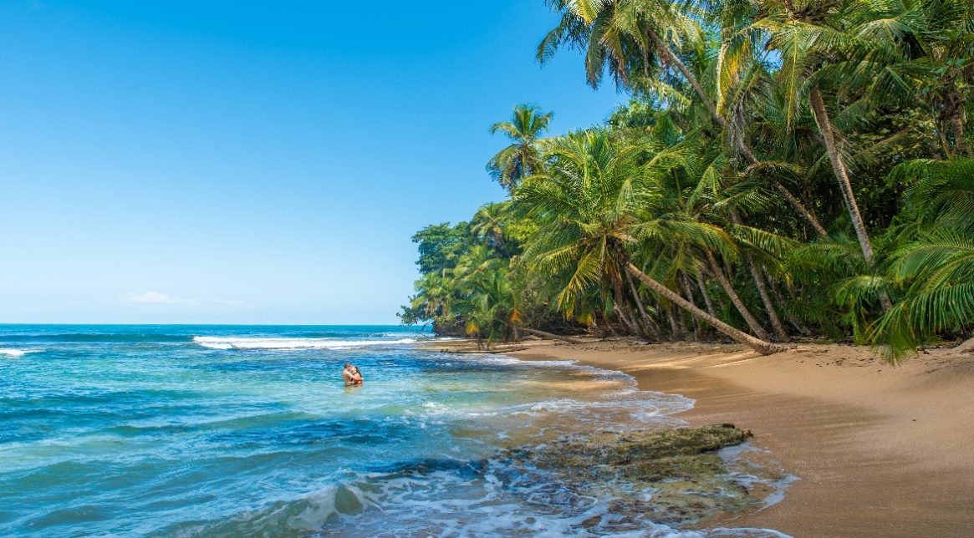

**Costa Rica**

**2024**

**HONEYMOON IN**

**Costa Rica**

**10 days / 9 nights**

2 nights in San José, 2 in Tortuguero, 2 in Arenal and 3 in Manuel Antonio

**Day 1. San José**

Arrival at **Juan Santamaría International airport in San José**. Shuttle transfer to your hotel. (Includes a welcome gift). Accommodation.

**Day 2. San José - Tortuguero (122 km)**

Early in the morning you will be heading to the **Tortuguero National Park**. Once you arrive to port **La Pavona**, a boat will take you through the famous canals and then to your hotel. During the evening you can visit the town of Tortuguero and some of the beaches located nearby. (Breakfast, lunch and dinner are included). Accommodation.

**Day 3. Tortuguero**

Free time in the morning. You can enjoy the hotel’s private hiking trails and a thrilling boat ride through the **Tortuguero** canals. At sunset, you will be boarding the Katonga boat to enjoy the wonderful view, some delicious appetizers, and a cocktail. (Breakfast, lunch and dinner are included). Accommodation.

**Day 4. Tortuguero - Arenal (220 km)**

**Breakfast**. On this day a boat is going to take you back to port **La Pavona**. You will be headed to **Arenal**, famous for its majestic 5300 feet tall volcano, hot springs, and natural pools. Free rest of the day to relax and explore around the area. (Welcome gift included). Accommodation.

**Day 5. Arenal**

**Breakfast**. Lay back and enjoy the hot springs, waterfalls and natural pools. During the evening, you can take some of the optional tours to the hanging bridges or a trip to the **La Fortuna** waterfall. Accommodation.

**Day 6. Arenal - Manuel Antonio (247 km)**

**Breakfast**. On this day you will be heading to **Manuel Antonio**, located in the Pacific Coast of Costa Rica. A place where the forest and the beach come together in one place. (Welcome gift included). Accommodation.

**Days 7 and 8. Manuel Antonio**

**Breakfast**. During these days, you can explore the spectacular nearby beaches, go for a hike, or visit the **Manuel Antonio National Park**, well known for its rich biodiversity, giant humid forest, white sand beaches and breathtaking coral reefs. Accommodation.

**Day 9. Manuel Antonio - San José (155 km)**

**Breakfast**. Early in the morning a shuttle will take you to **San José**, the capital of Costa Rica. Upon arrival, you may explore and enjoy the different tourist attractions such as the National Theater, The Metropolitan Cathedral and the Central Park. Accommodation.

**Day 10. San José**

**Breakfast**. A shuttle will take you back to the **Juan Santamaría International Airport**. End of our services.

**Optional:** You may complete this circuit in a rental car, starting on day 4 in Tortuguero until day 10. Ask your provider for prices.

|  |
| --- |
| **STARTING DAYS** |

Saturday, Sunday & Monday from January 10th till December 10th 2024. Easter time may have add-ons.

|  |
| --- |
| **INCLUDES** |

* Private arrival transfers to the **Juan Santamaría International Airport**
* Private departure transfer to the **Juan Santamaría International Airport**
* Regular transfers throughout the entire trip
* 02 nights of accommodation in San José in established hotels or similar
* 02 nights of accommodation in Tortuguero in established hotels or similar
* 02 nights of accommodation in Arenal in established hotels or similar
* 03 nights of accommodation in Manuel Antonio in established hotels or similar
* Daily breakfast, 3 lunches and 2 dinners
* Trips according to program
* Welcome gifts
* Access to Arenal hot spring complex
* Katonga boat tour in Tortuguero
* Local Taxes

|  |
| --- |
| **ADDITIONAL NOTES** |

* The order of the trip may vary.
* Mandatory payment (entry + taxes) is required to access the Tortuguero National Park ($17 per person)

|  |
| --- |
| **ESTABLISHED HOTELS** |

|  |  |  |
| --- | --- | --- |
| **San José** | Hotel Barceló San José Palacio  <https://www.barcelo.com/en-ww/barcelo-san-jose.html> | 2 nights |
| **Tortuguero** | Mawamba Lodge Tortuguero  [www.mawamba.com](http://www.mawamba.com) | 2 nights |
| **Arenal** | Tabacón Thermal Resort & Spa  [www.tabacon.com](http://www.tabacon.com) | 2 nights |
| **Manuel Antonio** | Karahé Beach Hotel  [www.karahe.com](http://www.karahe.com) | 3 nights |