OPTIONAL TOURS



**SAN JOSÉ**

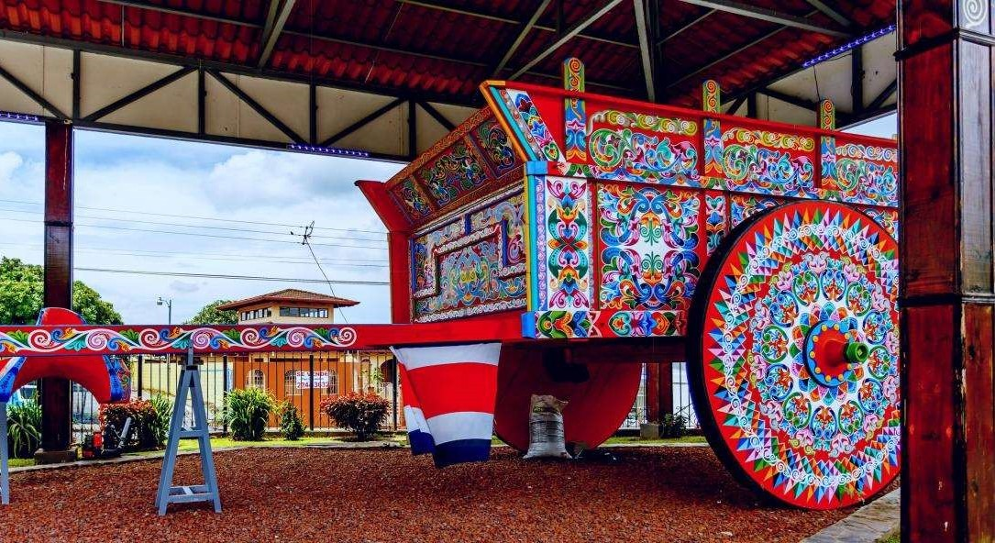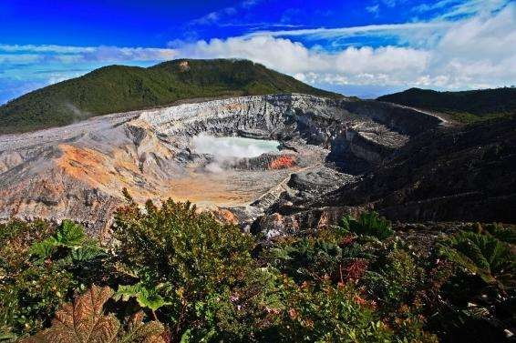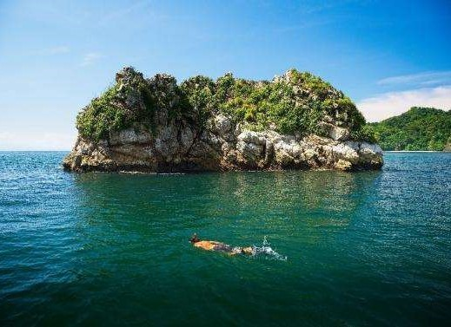

# “CULTURE AND MYSTICAL” TOUR

## Description:

Truly an innovative City tour! We will take you to San Jose from your hotel to witness the main historical landmarks of the city, to create a cultural experience for a better understanding of the evolution of Costa Rica. After visiting the San José (the capital of Costa Rica), we will leave for Ciudad Colón where we will live an unforgettable experience visiting the Virilla Caves, an experience that is going to give you a clearer picture about the natural and architectural wealth of Costa Rica.

**Includes:**

* Round trip transportation
* Bilingual guide (Spanish / English)
* Tour in San José and the Virilla Caves
* Lunch

**What to bring?**

* Camera
* Insect repellent
* Sunblock
* Daily departures
* Approx duration: **5 hours**
  + Departure from the hotel approx.: 9:00
  + Arrival at hotel approx.: 14:30
* Minimum 2 pax

.

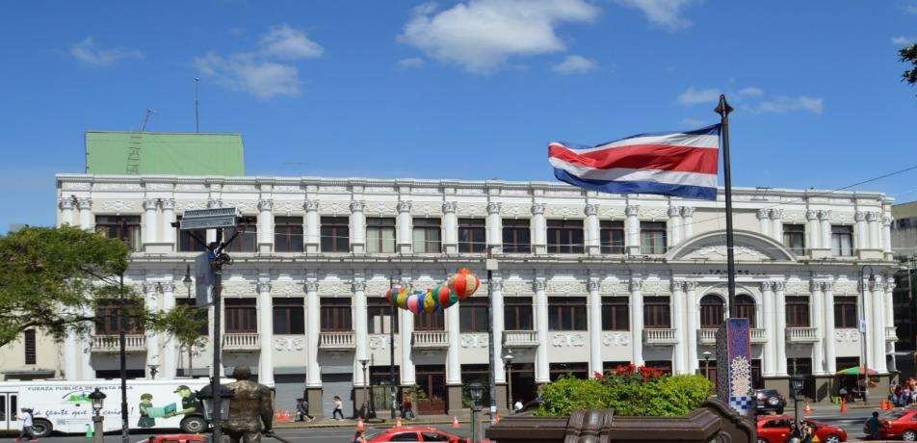

# AMAZING VOLCANOES

## Description:

You can choose between either of these two colossal volcanoes:

* Poás Volcano tour: As we ascend towards the Poás volcano, we will be able to appreciate the difference of microclimates and vegetation, observing the great agricultural diversity such as: flowers, strawberries, ornamental plants, as well as the livestock farms and the view of the central valley creating a beautiful landscape. This 2708 meter (8,885 feet) tall colossus is currently active. You will not only admire its impressive crater and gas fumes, but also learn about its phreatic and fumarolic activity, in addition to the different ecosystems and lush vegetation found in this beautiful national park.
* Irazú Volcano tour: The tour starts as we drive through the Pan-American Highway, ascending little by little towards the Irazú Volcano National Park. We will cross the fertile cultivated lands with all kinds of vegetables, while observing a mountainous and curvy path with beautiful panoramic views of the city of Cartago. On a clear and cloudless day, it is possible to see the Pacific Ocean and the Caribbean Sea from the top of the volcano.

**Includes:**

* Round trip transportation
* Bilingual guide (Spanish / English)
* Entrance to Poás Volcano or Irazú Volcano

**What to bring?**

* Camera
* Insect repellent
* Raincoat
* Light jacket or sweatshirt
* Walking shoes
* Daily departures
* Approx duration: **4 hours**
  + Departure from the hotel approx.: 7:30
  + Arrival at hotel approx.: 11:30
* Minimum 2 pax

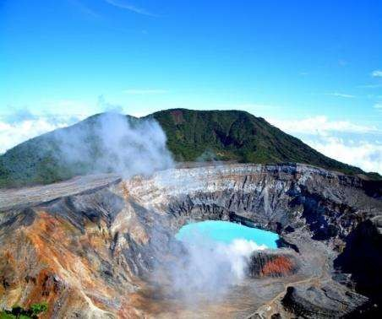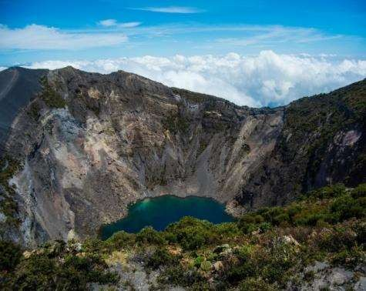

# GOLDEN COFFEE BEAN

## Description:

If you want to discover the secrets of good coffee this is the ideal half-day tour for you! No more than an hour from the capital, you will have the opportunity to learn about the cultural richness that coffee has for Costa Ricans. You can enjoy a unique experience and learn everything related to cultivation, processing, and good practices, as well as the natural and cultural environment in a coffee plantation.

* Daily departures

**Includes:**

* Round trip transportation
* Bilingual guide (Spanish / English)
* Coffee tour

**What to bring?**

* Camera
* Insect repellent
* Sunblock
* Approx duration: **4 hours**
  + Departure from the hotel approx.: 9:00
  + Arrival at hotel approx.: 13:00
* Minimum 2 pax

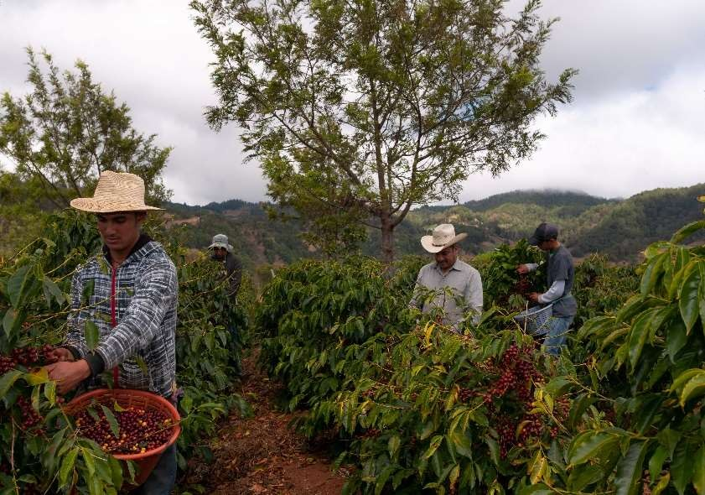

# IN THE CLOUDS

## Description:

We will start the tour driving to the majestic and imposing Irazú volcano. The path surrounded by green fields, will take us through fertile land cultivated with a wide variety of vegetables such as potatoes, onions, carrots, and other local produce. At the top of the Irazú volcano national park, the main craters will be observed. This volcano is the highest in Costa Rica at 3,432 meters (11,000 feet) above sea level. On a sunny, cloudless day, both the Atlantic and Pacific oceans could be observed. After the visit to the Irazú volcano, we will descend to the city of Cartago, the old capital of Costa Rica established in 1563. Here, we will visit the Basílica of the Virgen de Los Ángeles. Then we will continue to the Orosí Valley, which has beautiful landscapes, surrounded by beautiful mountains cultivated with coffee, sugar cane and ornamental plants, among others. The town of Orosí was the protagonist of important historical and religious events during the colonial era, whose inherited vestiges have been declared national historical monuments. The beautiful Colonial Church of Orosí which is still open to the public, definitely stands out. You will have the chance to visit this place after a delicious typical lunch. Later that day you will go back to San José.

**Includes:**

* Round trip transportation
* Bilingual guide (Spanish / English)
* Entrance to the Irazú Volcano
* Visit to the Basilica Nuestra señora de Los Angeles
* Lunch

**What to bring?**

* Camera
* Insect repellent
* Raincoat
* Light jacket or sweatshirt
* Walking shoes
* Daily departures
* Approx duration: **9 hours**
  + Departure from the hotel approx.: 7:30
  + Arrival at hotel approx.: 16:00
* Minimum 2 pax

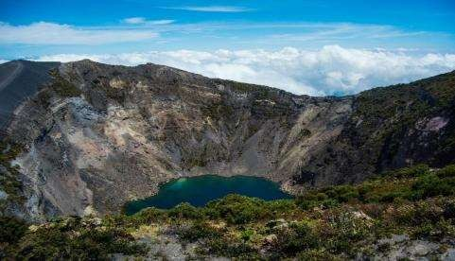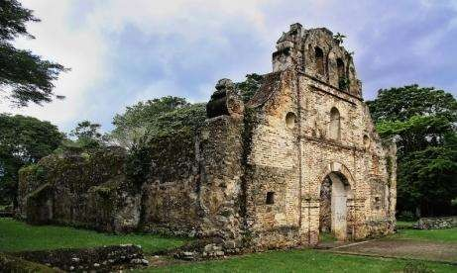

# ECO – TOUR

## Description:

On the way to the Poás Volcano you will be able to observe the Monument to the Farmer, the Monument to Juan Santamaría and the famous Park of the Mangoes (Mangos). As the bus ascends to the volcano, we will make a stop to enjoy the panoramic view of a coffee plantation in the "Casita del Café" where we will give a brief explanation about the "Golden Bean". We will continue to ascend through crops of ferns, flowers, and strawberries until we reach the national park, where you can appreciate a huge variety of vegetation. Upon reaching the volcano, we will take the time to observe the amazing active main crater, with its impressive fumaroles. Later that day we will take a walk along the road that will allow us to view the different ecosystems. We will continue to "La Paz Waterfall Gardens", a natural park and wildlife refuge, where the green trails that will take us to the spectacular waterfalls, surrounded by the rainforest. Inside the park there is a butterfly and hummingbird observatory, a feline rescue center, monkeys, birds, orchids, frogs and a serpentarium.

**Includes:**

* Round trip transportation
* Bilingual guide (Spanish / English)
* Entrance to Poás Volcano National Park
* Entrance to La Paz Waterfalls
* Lunch

**What to bring?**

* Camera
* Insect repellent
* Raincoat
* Light jacket or sweatshirt
* Walking shoes
* Daily departures
* Approx duration: **10 hours**
  + Departure from the hotel approx.: 7:30
  + Arrival at hotel approx.: 16:30
* Minimum 2 pax

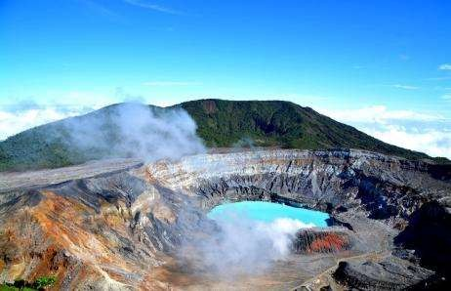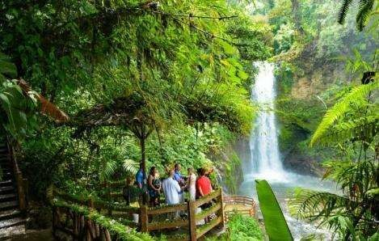

# FERTILE LAND

## Description:

During this trip we will explore the fertile area of Sarapiquí, on the Caribbean coast of Costa Rica. We will visit a cocoa plantation and learn about the process of making chocolate. The tour continues with a hike through the private trails of the green jungle at Eco Lodge, which is a paradise for nature lovers! A boat tour on the Sarapiquí River is also included, you will be able to observe birds, reptiles, and mammals in their natural habitat.

**Includes:**

* Round trip transportation
* Bilingual guide (Spanish / English)
* Chocolate tour
* Boat tour on the Sarapiquí River
* Lunch

**What to bring?**

* Camera
* Insect repellent
* Raincoat
* Light jacket or sweatshirt
* Walking shoes
* Hat
* Daily departures
* Approx duration: **10 hours**
  + Departure from the hotel approx.: 7:30
  + Arrival at hotel approx.: 16:30
* Minimum 2 pax

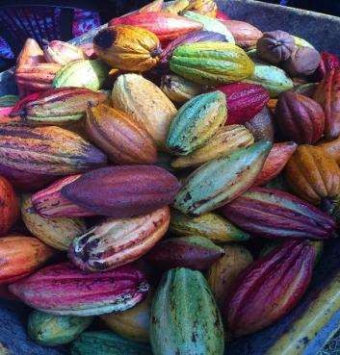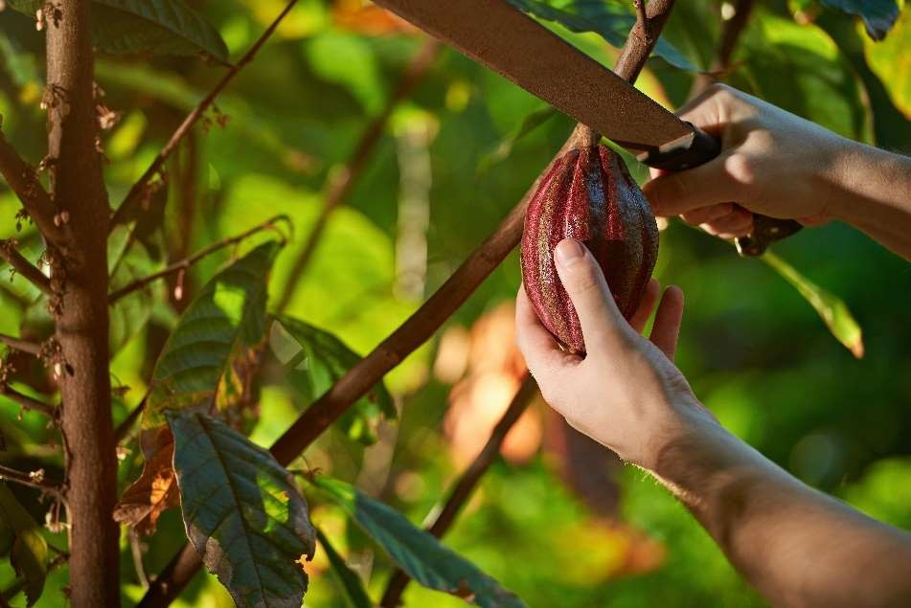

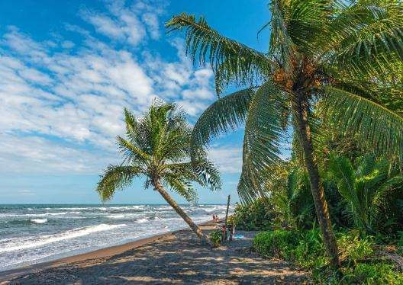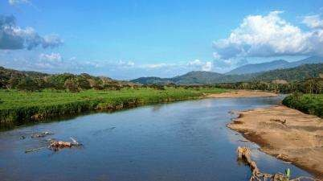

# RELAX BY THE BEACH

## Description:

We will leave the Central Valley and drive to the Central Pacific coast, through beautiful mountainous areas, passing through the village of Orotina, a region well known for the production and sale of delicious fresh fruits. On our way there, we will stop to observe from a safe distance, the crocodiles that live in the Tárcoles River. Once we arrive at Jacó Beach, all we have to do is enjoy the rest of the day of relaxing at a beachfront hotel with the all-inclusive system.

**Includes:**

* Round trip transportation
* Bilingual guide (Spanish / English)
* Crocodile watching at Tárcoles River
* Access to hotel ALL INCLUSIVE
* Unlimited food, snacks and drinks

**What to bring?**

* Camera
* Insect repellent
* Sunblock
* Swimsuit
* Towel
* Water shoes or sandals
* Hat
* Daily departures
* Approx duration: **10 hours**
  + Departure from the hotel approx.: 7:00
  + Arrival at hotel approx.: 18:30
* 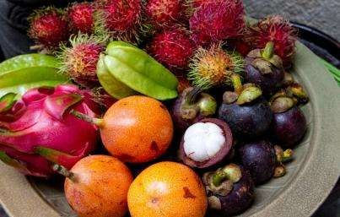Minimum 2 pax

# THERMAL - THERAPY

## Description:

The Arenal Volcano is one of the most beautiful volcanoes in America. Our first stop will be at the Metallic Church in the city of Grecia, a place that is internationally recognized for the cleanliness of its streets and their friendly people. Our tour continues to the colorful artisan Town of Sarchí, where beautiful handicrafts, furniture and hand-painted carts are manufactured and exhibited. These were used years ago as means of transport for coffee and other agricultural products for export. Then we will visit the Sarchí Park to admire the largest Oxcart in the world and the oxcart factory, where many handmade objects are exhibited and sold daily. We will continue along a mountainous path to a restaurant to enjoy a delicious typical lunch. Our last stop is in La Fortuna, where the colossal Arenal Volcano is located. It has a conical shape and underground rivers of hot springs. The Baldi resort is where we will enjoy for several hours the relaxing outdoor pools with mineral thermal waters, while we will admire the splendor and beauty of the Arenal Volcano.

**Includes:**

* Round trip transportation
* Bilingual guide (Spanish / English)
* Visit to the town of Grecia and Sarchí
* Baldi Hot Springs ticket with lunch and dinner

**What to bring?**

* Camera
* Insect repellent
* Sunblock
* Swimsuit
* Water shoes
* Daily departures
* Approx duration: **13 hours**
  + Departure from the hotel approx.: 7:30
  + Arrival at hotel approx.: 20:30
* Minimum 2 pax

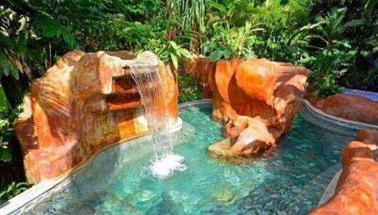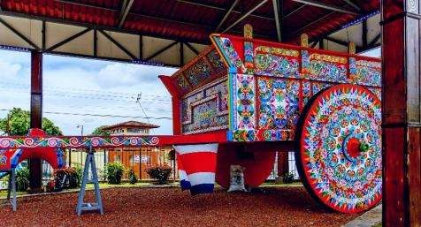

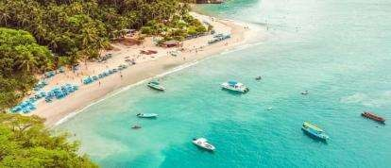

# TURTLE ISLAND

## Description:

We will leave the Central Valley and drive to the Pacific coast to the city of Puntarenas, through beautiful mountainous areas. From there we will take a boat to visit Tortuga Island, located 12 nautical miles from Puntarenas. Tortuga Island is a sanctuary of white sand beaches and turquoise waters that houses sea birds, flora and fauna of the Central Pacific. With an area of 120 hectares this place maintains a protected forest that was awarded with the Ecological Blue Flag; distinction that is given to beaches of our country that have waters free of pollution.

**Includes:**

* Round trip transportation
* Bilingual guide (Spanish / English)
* Catamaran tour with lunch
* Unlimited fruits and non-alcoholic beverages

**What to bring?**

* Camera
* Insect repellent
* Sunblock
* Swimsuit
* Towel
* Water shoes or sandals
* Hat
* Departures: Wednesday to Sunday
* Approx duration: **14 hours**
  + Departure from the hotel approx.: 6:00
  + Arrival at hotel approx.: 20:30
* 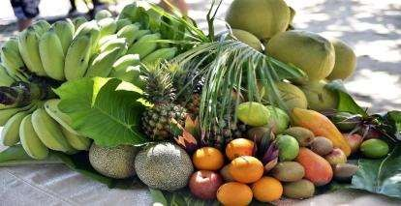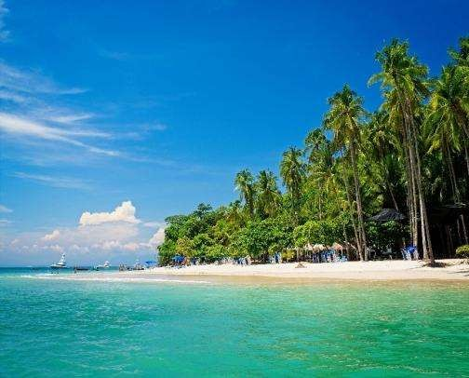Minimum 2 pax

# AN AMAZING PARK: Manuel Antonio

## Description:

We will leave the Central Valley and drive to the Central Pacific coast, through beautiful mountainous areas, passing through the village of Orotina, a region well known for the production and sale of delicious fresh fruits. On our way there, we will stop to observe from a safe distance, the crocodiles that live in the Tárcoles River. Our tour continues to the coastal area of Quepos in Puntarenas, where the wonderful Manuel Antonio National Park is located. We are going walk inside the park until we reach the beautiful beach, where the greenery of the forest comes together in one place. In addition to beaches, the Park offers a very humid tropical forest where species of flora and fauna in danger of extinction coexist, a mangrove, marine environments, islands and a lagoon.

**Includes:**

* Round trip transportation
* Bilingual guide (Spanish / English)
* Crocodile watching at Tárcoles River
* Entrance to Manuel Antonio National Park
* Snacks and lunch

**What to bring?**

* Camera
* Insect repellent
* Sunblock
* Swimsuit
* Towel
* Sandals
* Daily departures (except Tuesdays)
* Approx duration: **12 hours**
  + Departure from the hotel approx.: 7:00
  + Arrival at hotel approx.: 19:00
* Minimum 2 pax

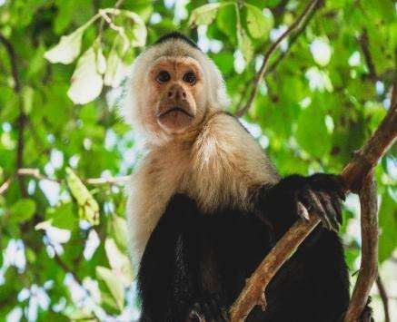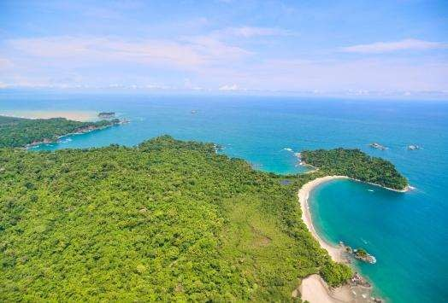



01/September/2023

