OPTIONAL TOURS



**GUANACASTE**

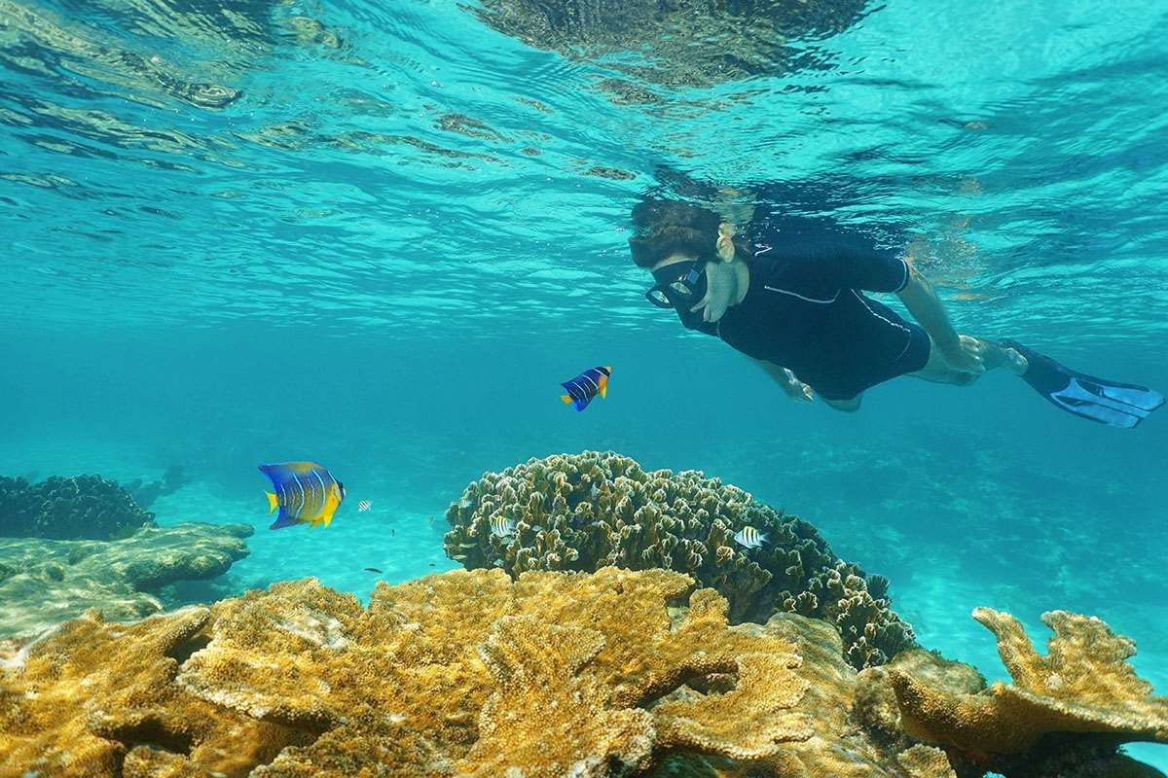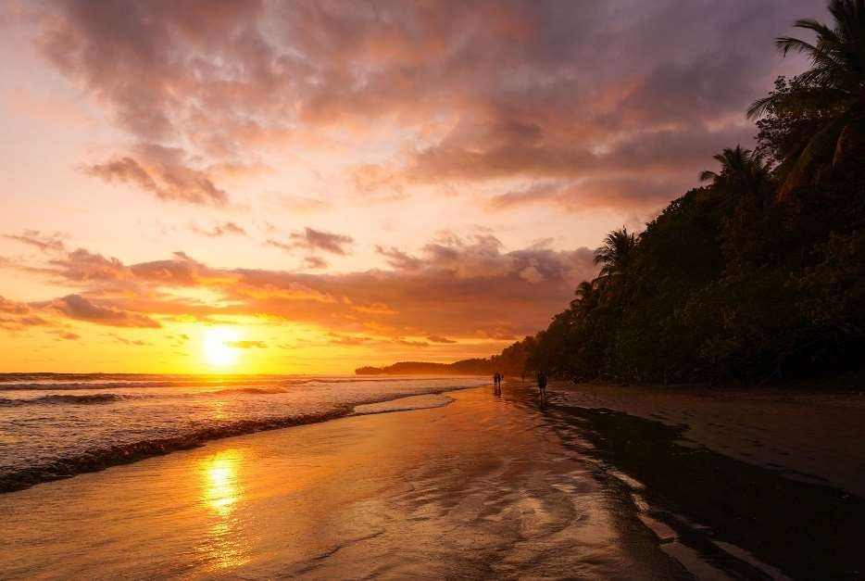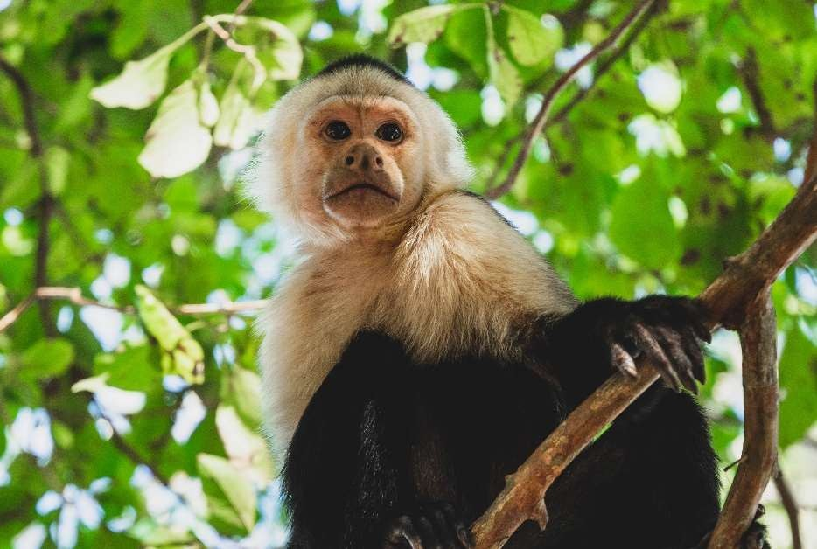

**1. CANOPY TOUR IN DRY FOREST**

What better way to enjoy the Tropical Dry Forest than gliding through it! feeling like the birds do while they fly over this beautiful environment, or as the monkeys do when they swing off of the tree branches. Special and certified climbing gear in combination with several steel cables will take you through the forest canopy from platform to platform in a very exciting and safe way. You will be able to enjoy the different perspectives of the forest. Our guides will point out the marvelous secrets of these unique and sparse types of forest.

* Daily departures

**Includes:**

* Transportation
* Bilingual naturalist guide
* Entrance fee
* Bottle of water
* Approx. duration: **Half day**
* Minimum 2 pax

**2. TAMARINDO MAGROVE & ESTUARY TOUR ON BOAT**

Estuaries play a very important part in nature, as its hosts several tree species such as the mangroves. It’s also home for several species of birds and animals. They also are a very important natural barriers to avoid floods and protects coasts and beaches around the world from tropical storms. The Tamarindo Estuary is one of the largest estuaries in Guanacaste Coast, also part of Las Baulas National Park - famous for being one of the nesting spots for Leatherback and Pacific Green Turtles. The tour offers a unique opportunity to observe the generous wildlife living in this oasis. This is a very rich ecosystem, where dozens of animals interact with each other and trees filter water to and from the sea, thanks to mangrove forest. We will enjoy the estuary on a comfortable motor boat, that will lead us thru this protected sanctuary for wildlife. Navigating on the wetland you will be able to spot animals such as: iguanas, crocodiles, turtles, lizards and lots of different species of birds. Half way through the mangrove tour you will have the chance to get off the boat and walk into the national park, where we may see the howler monkeys, raccoons and other animals exclusive of this place.

* Daily departures

**Includes:**

* Transportation
* Bilingual naturalist guide
* Entrance fee
* Bottle of water
* Approx. duration: **Half day**
* Minimum 2 pax

**3. PALO VERDE NATIONAL PARK BOAT TOUR & LUNCH**

The hydrologic characteristics of the Tempisque River has created conditions to form these international important wetlands ecosystems (Ramsar site). Palo Verde National Park it is an exceptional place for birdwatchers and nature lovers in general. A two hours boat trip will introduce us to these important ecosystem, gigantic crocodiles, monkeys, iguanas and more wildlife that you ever imagined may be spotted. Great bird-watchers’ prizes can show up, such as the Jabiru, osprey, the white ibis, tiger herons, and scarlet macaws amongst others. After the boat tour we will head to a rustic place to have a delicious typical lunch and close this wonderful excursion with a delicious culinary experience.

**Includes:**

* Transportation
* Bilingual naturalist guide
* Lunch
* Bottle of water
* Daily departures
* Approx. duration: **Full day**
* Minimum 2 pax

**4. COASTAL KAYAK & SNORKELING ON TAMARINDO BAY**

As you row through the blue smooth waters of Tamarindo beach towards the white sand Capitán Island, you will be able to enjoy the beautiful colors of the water and observe underwater coral reef, and exotic fish.

* Daily departures

**Includes:**

* Transportation
* Bilingual naturalist guide
* Kayaks
* Equipment
* Bottle of water
* Approx. duration: **Half day**
* Minimum 2 pax

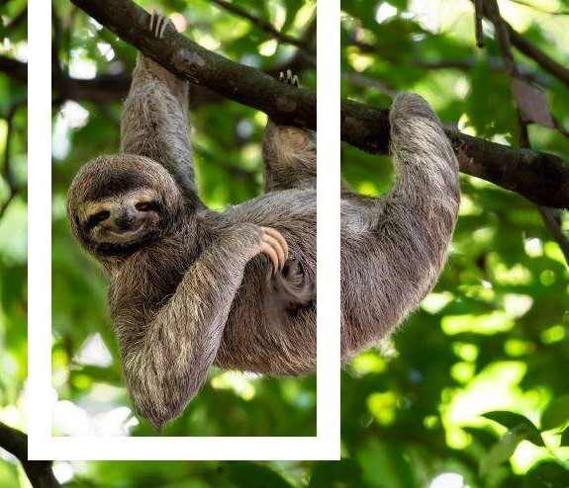



01/September/2023