OPTIONAL TOURS



**JACÓ**

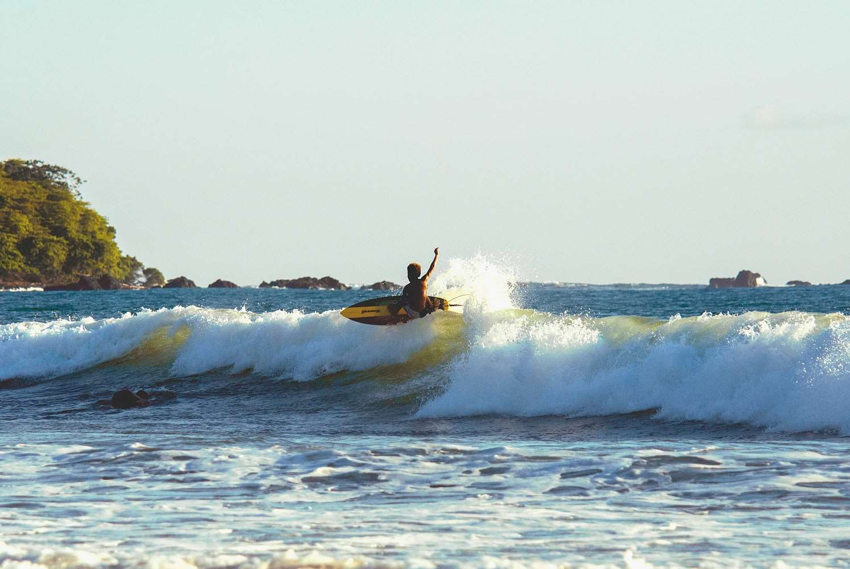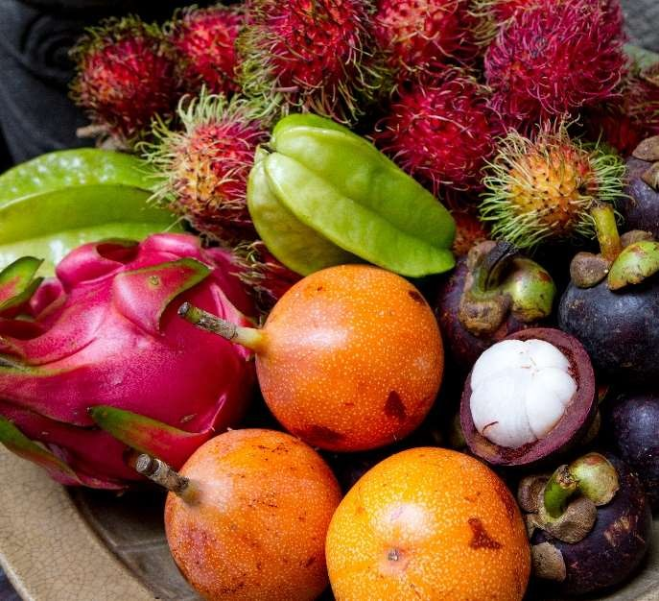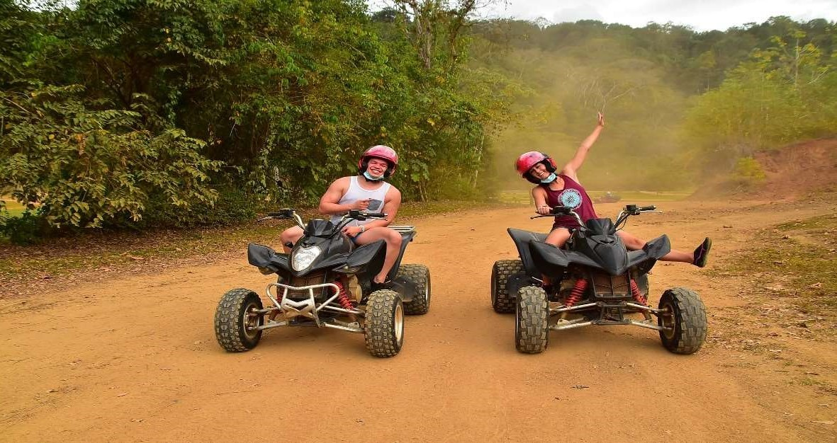

**1. CARARA NATIONAL PARK**

Our tour starts with a 25-minute drive from the Jaco area to Carara National Park. This incredible protected area measures about 4,700 hectares and is home to approximately 48% of Costa Rica’s aviary species. This tour will show you the importance of the region, as it is situated between the tropical dry forest and the humid pacific rainforest. Carara National Park showcases colorful species of flora and fauna from a rich ecosystem. This sanctuary is populated by many different species of birds and animals, amongst them the white face and howler monkeys, iguanas, toucans and trogons. Carara also holds an important population of scarlet macaws, the main attraction in town.

* Daily departures

**Includes:**

* Transportation
* Bilingual naturalist guide
* Entrance fee
* Bottle of water
* Approx. duration: **Half day**
* Minimum 2 pax

**2. COCODRILE RIVER CRUISE**

Come observe the Great American Crocodile in our famous river safari on the Tárcoles River. Our captain will surely spot the biggest crocodiles in the river for you to enjoy a great up-close encounter with these magnificent reptiles. You will be amazed by the wide diversity of birds you can find in this area. Your guide will point out the different kinds of mammals, birds and reptiles that flourish in this mangrove system. Depending on the season, you will be able to spot different migratory aviary species; from October to April, you can glimpse ospreys, gulls, cormorants, pelicans, and frigates. The Tárcoles River is a shelter for approximately 56 types of birds and is a refuge for the famous scarlet macaws as well.

* Daily departures

**Includes:**

* Transportation
* Bilingual naturalist guide
* Entrance fee
* Covered boat
* Bottle of water
* Approx. duration: **Half day**
* Minimum 2 pax

**3. ATV TOURS**

The tour begins with a drive towards the big green mountains, away from the Pacific Ocean. We will take a dirt road going up to the top! We will be able to clearly see the entire coastline and the Nicoya Peninsula. The rainforest is so plentiful and filled with vivid green colors. Ready for more? We’ll get back on our quads and start the descent back down the mountain. This is a bit more technical than the climb up, the mountain side really gives you the perspective of how high we really are above sea level.

**Includes:**

* Transportation
* Bilingual naturalist guide
* Entrance fee
* Machine, gear and insurance
* Bottle of water
* Daily departures
* Approx. duration: **Half day**
* Minimum 2 pax

**4. CANOPY TOUR LOS SUEÑOS**

This Canopy is a Project designed not only as an extreme adventure, but also to enjoy nature without harming the environment. The property boasts spectacular views of the Herradura bay and Island, as well as the Nicoya Gulf. Within the property, you will have the opportunity to view the Scarlet Macaws, Chestnut mandible Toucans and whiteface monkeys. The property rests on 80 acres of land, 50% of which is primary forest, where the canopy is located. The adventure starts on a 15-minute ride aboard our specially designed 40-passenger tractor. Once we arrive to the top of the mountain, we then descend to the bottom via a series of zip lines, including 15 platforms and 14 cables, with a total cable distance of

* 1. kilometer including the longest cable in the area of 2400 ft!
     + Daily departures

**Includes:**

* Transportation
* Bilingual naturalist guide
* Entrance fee
* Equipment
* Bottle of water
  + - Approx. duration: **Half day**
    - Minimum 2 pax

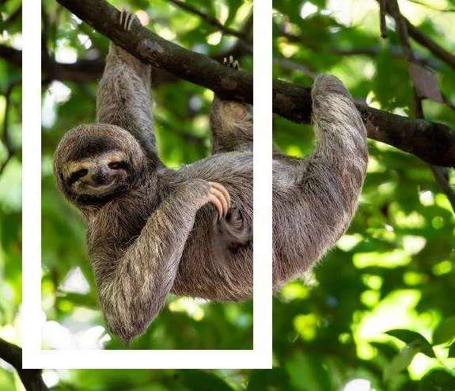



01/September/2023