OPTIONAL TOURS



**MANUEL ANTONIO**

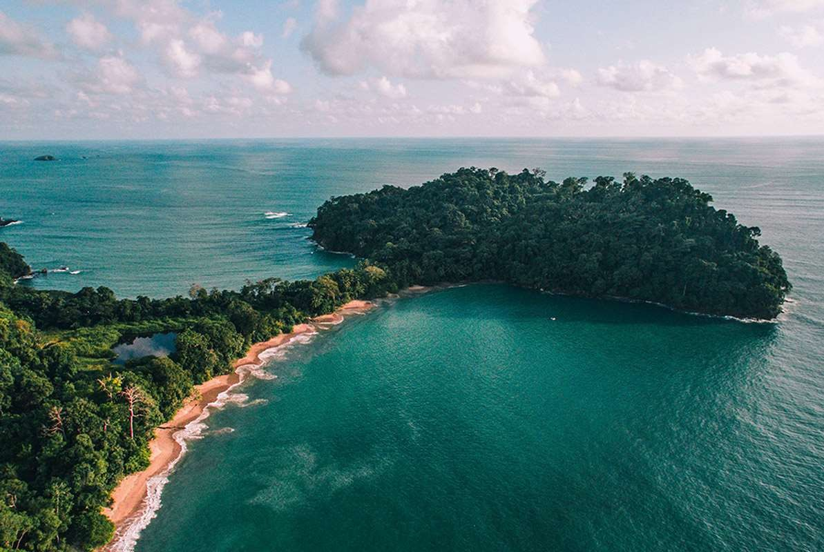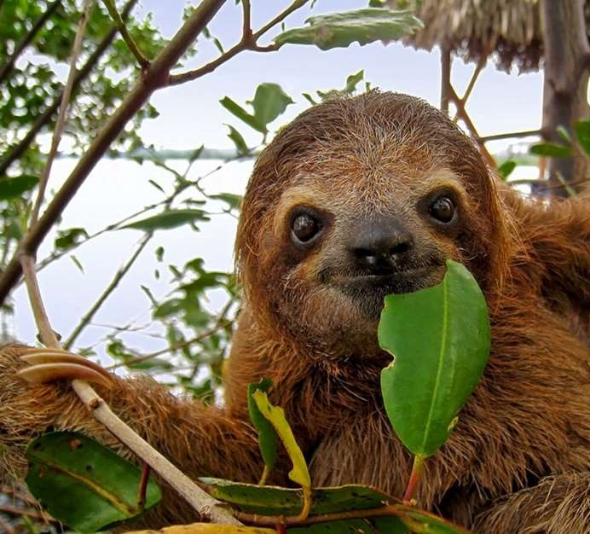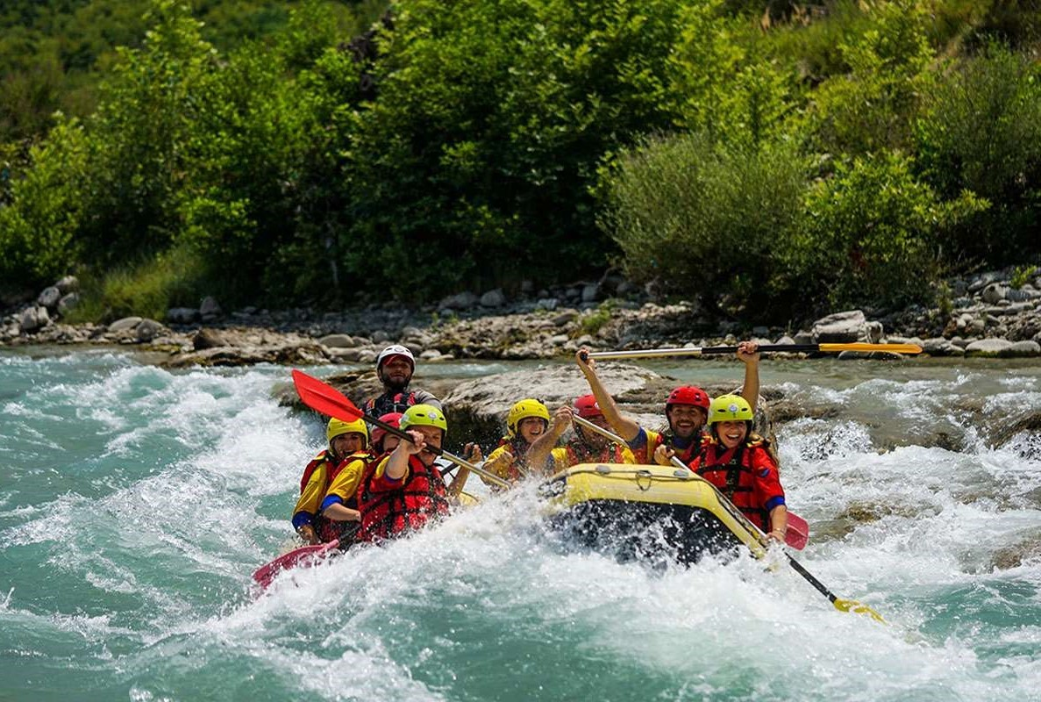

**1. MANUEL ANTONIO NATIONAL PARK**

Manuel Antonio National Park is the most visited national park in Costa Rica. This protected area is very popular due to its great variety of flora and fauna. The park consists of several beaches, mangroves, dry and wet coastal forests. An experienced guide will accompany you in this picturesque oasis of life where you will be amazed by its natural wonders. Amongst the most common fauna we can find: monkeys, birds, iguanas, crabs, sloths and some other mammals. This coastal reserve contains the most important population of the Squirrel Monkey or "Tití" Monkey in Costa Rica, the smallest and most threatened species of monkeys in the country. This tropical paradise is the perfect place to enjoy walking on beautiful white sand beaches or having the opportunity to jump in the clear ocean water (specially on a sunny warm day), all of this in an idyllic environment surrounded by tropical rain forest. After touring the national park, we can’t leave Manuel Antonio without having a delicious lunch with a great ocean view.

* Daily departures

**Includes:**

* Transportation
* Bilingual naturalist guide
* Entrance fee
* Lunch
* Bottle of water
* Approx. duration: **Half day**
* Minimum 2 pax

**2. SAVEGRE WHITE WATER RAFTING**

Get ready for a day of adrenaline and extreme fun! You will enjoy the scenic road trip as it takes you over winding gravel roads through remote countryside landscapes. While you are attempting to tame the rapids of Savegre River, your guide will be riding beside you to ensure your safety. This river features class II and class III rapids. Once you reach the end of the river, you will be able to take a closer look at your surroundings and admire the colorful flora and fauna. Your guide will lead you to a stunning waterfall where you will stop to admire the scenery and for snacks. You can take advantage of this relaxing pause and swim a little in the calm pond nearby. Your guide will help you find notable species of primary jungle vegetation. You will also be served a delicious homemade meal for lunch.

**Includes:**

* Transportation
* Bilingual naturalist guide
* River gear
* Lunch
* Fruits and bottle of water
* Daily departures
* Approx. duration: **Half day**
* Minimum 2 pax

**3. CATAMARAN ADVENTURE**

You will set sail towards the horizon and cruise over sapphire hued waves. The catamaran will chart a picturesque course departing from Quepos gliding around the back of Manuel Antonio National park. Your guide will point out notable wildlife and vegetation specimens, so be sure to have your camera ready. You will pass gorgeous landscapes adorned with islands, cliffs and rock formations. You can admire aviary nesting grounds and marine wildlife. Beverages and snacks are available onboard the catamaran throughout the trip. After touring the coastline, your captain will set anchor on Bisanz beach where you can take advantage of the pit stop to snorkel around this secluded bay. You are most likely to spot parrotfish, starfish, angelfish and if you are lucky a dolphin! During your chartered course you will be able to savor a tasty barbeque lunch onboard the catamaran while admiring the lovely waterscapes. You will then head back to the dock where there will be transportation waiting to take you back to your hotel.

* Daily departures

**Includes:**

* Transportation
* Bilingual naturalist guide
* Lunch
* Snacks and beverages
* Approx. duration: **Full day**
* Minimum 2 pax

**4. ATV TOURS**

The tour begins with a drive towards the big green mountains, away from the Pacific Ocean. We will take a dirt road going up to the top! We will be able to clearly see the entire coastline and the Nicoya Peninsula. The rainforest is so plentiful and filled with vivid green colors. Ready for more? We’ll get back on our quads and start the descent back down the mountain. This is a bit more technical than the climb up, the mountain side really gives you the perspective of how high we really are above sea level.

**Includes:**

* Transportation
* Bilingual naturalist guide
* Entrance fee
* Machine, gear and insurance
* Bottle of water
* Daily departures
* Approx. duration: **Half day**
* Minimum 2 pax

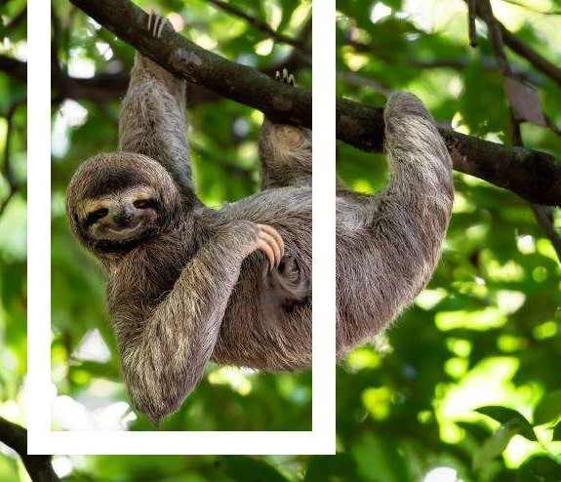



01/September/2023