OPTIONAL TOURS



**PUERTO VIEJO**

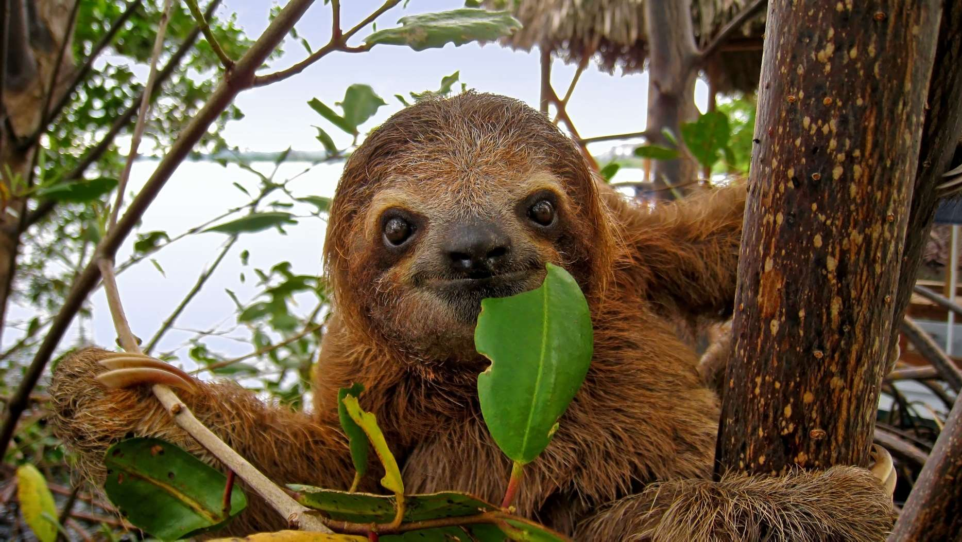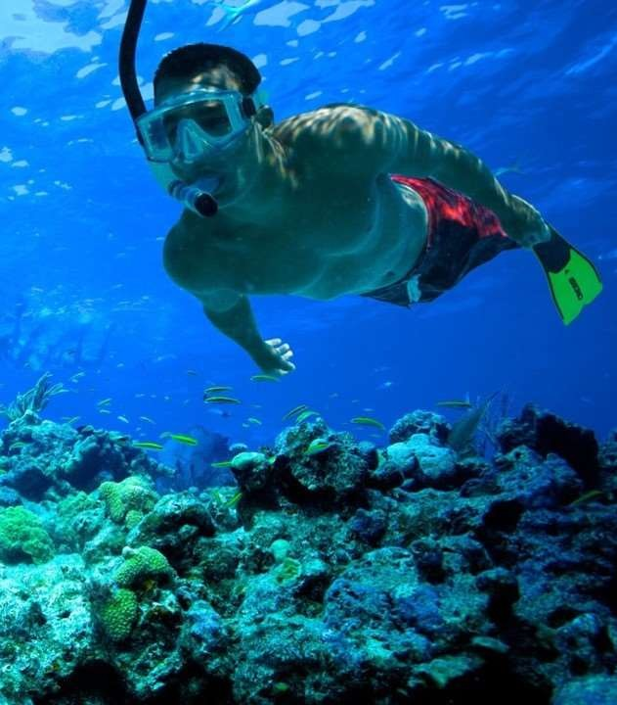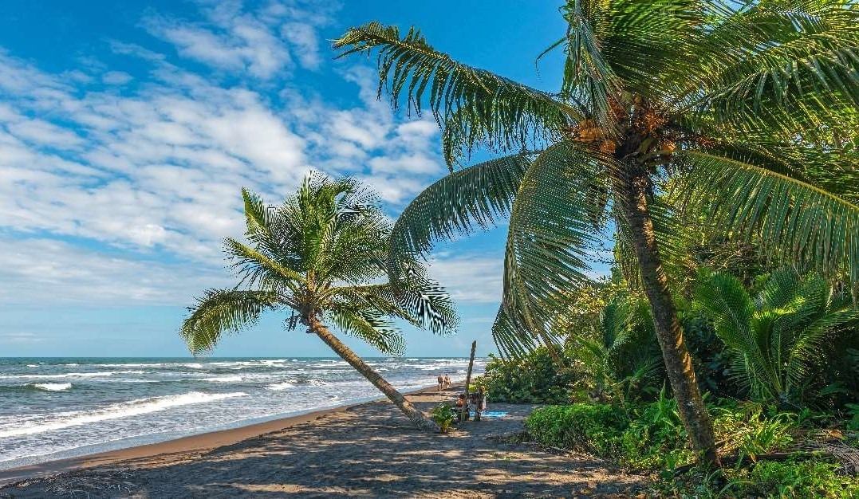

**1. INDIGENOUS EXPERIENCE**

Just a few kms passed Bri Brí, the administrative center of the Talamanca area, is the Area of Conservation of the Indigenous People, land preserved for different etnias. During your visit, you will learn about the traditions of a typical Bri Brí family, their history, culture, beliefs, their great knowledge of medicinal plants, and you will enjoy observing their building techniques and discovering a different way of life. You will also treat yourself with chocolate making and sampling, and of course, learning about this great gift of nature. The trip will end with a nice stop at one of the local waterfalls, where you get to go for a swim.

**Includes:**

* Transportation
* Bilingual naturalist guide
* Entrance fee
* Snacks and bottle of water
* Daily departures
* Approx. duration: **Half day**
* Minimum 2 pax

**2. PUNTA UVA SEA KAYAK & RAINFOREST HIKE**

We will drive to the most beautiful location in the area, Punta Uva. This trip consists of three sections. After a safety briefing we will first embark in a magical Punta Uva sea kayaking journey paralleling a coast full of cliffs, caves, and the most amazing rainforest. Then we will paddle our way up river though gorgeous rainforest where you can expect to spot monkeys, sloth, colorful birds, river turtles, bats and iguanas. Your professional guide will deliver a lot of interesting insights on this wonderful eco system. Back at the beach we will take a nice break to relax, swim and enjoy some nicely presented fresh fruit and snacks before hiking to the great over view at Grape Point.

* Daily departures

**Includes:**

* Transportation
* Bilingual naturalist guide
* Equipment
* Snacks and bottle of water
* Approx. duration: **Half day**
* Minimum 2 pax

**3. CAHUITA SNORKELING AND RAINFOREST HIKE**

Cahuita National Park has the largest system of Coral Reefs in Costa Rica, including 6 species of coral, a wide range of colorful tropical fishes and the occasional encounter of a harmless reef shark or stingray. This beach has a horse shoe shape, with the entrance of the park at one end and beautiful Punta Cahuita at the other end. We start with a scenic 20 minute boat ride to have two snorkeling sessions. Then we get drop off at the Punta to enjoy a delicious fruit and snacks break at the beach followed by a 1 hour guided hike in this wonderful coastal forest: monkeys, sloths, birds, poison dart frogs, iguanas and other interesting encounters are common.

* Daily departures

**Includes:**

* Transportation
* Bilingual naturalist guide
* Equipment
* Snacks and bottle of water
* Approx. duration: **Half day**
* Minimum 2 pax

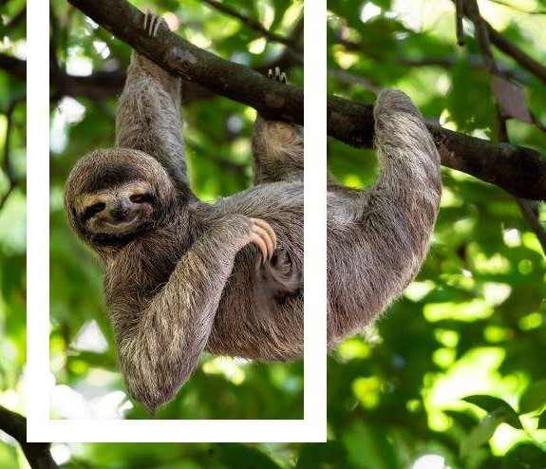



01/September/2023