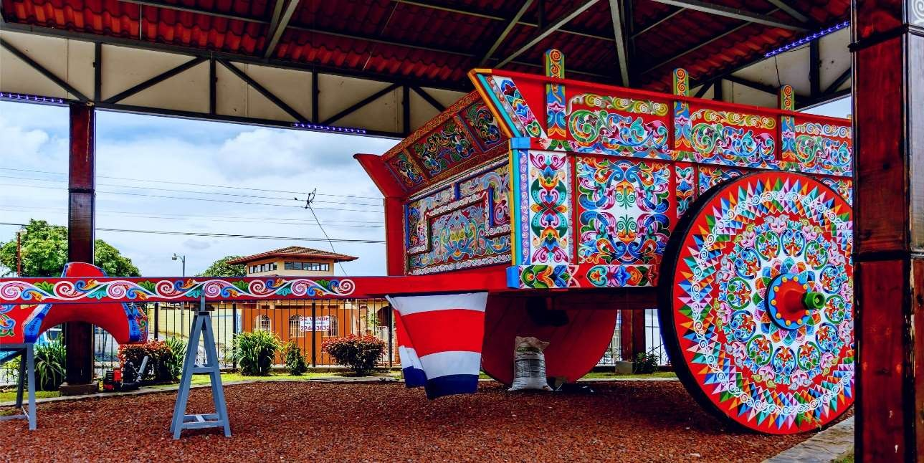

**Costa Rica 2024**

# San José COMPLETE

**08 days / 07 nights**

7 nights in San José

## DAY 1. SAN JOSÉ

Arrival at **Juan Santamaría International airport in San José**. Shuttle transfer to your hotel. Free time. Accommodation.

## DAY 2. SAN JOSÉ

**Breakfast. Culture and mystical tour.** Truly an innovative City tour! We will take you to San Jose from your hotel to witness the main historical landmarks of the city, to create a cultural experience for a better understanding of the evolution of Costa Rica. After visiting the San José (the capital of Costa Rica), we will leave for Ciudad Colón where we will live an unforgettable experience visiting the Virilla Caves, an experience that is going to give you a clearer picture about the natural and architectural wealth of Costa Rica. Free rest of the day. Accommodation.

## DAY 3. SAN JOSÉ

**Breakfast. Tour to the Volcán Poás National Park and La Paz Waterfall Gardens.** Early in the morning we are heading to the Poás volcano. Our first stop is at la Casita del Café, where we will receive a brief explanation about the fascinating history of coffee. Breathtaking nature and an impressive cloud forest welcome you as we arrive to our first main destination; the Volcán Poás National Park. You will be able to admire the volcano’s active crater as well as its incredible fumaroles. Later in the day, we are heading to La Paz Waterfall Garden,

a natural park and wildlife refuge surrounded by jungle and amazing waterfalls. We will visit their butterfly and hummingbird garden and a feline rescue center. Free rest of the day. Accommodation.

## DAY 4. SAN JOSÉ

**Breakfast. Tour to the Irazú Volcano, The Basílica de Los Angeles and the Orosí Valley**. Our day starts early in the morning, we are heading to the majestic and spectacular Irazú Volcano. On our way to there, we will be able to admire the green fertile fields where locals grow different types of vegetables such as potatoes, onions, and carrots. The Irazú is the tallest volcano in Costa Rica, if the weather conditions allow it, the Atlantic and Pacific Ocean can be seen from afar. Our Shuttle will then descend to the city of Cartago, the old capital of Costa Rica. Quick stop at the Basílica de los Ángeles. Later in the day we will be heading to our next destination; the Orosí Valley, a place surrounded by beautiful mountains and coffee plantations. This city was the protagonist of several historic and religious events during the colonial period. Lunch on site. Free rest of the day. Accommodation.

## DAY 5. SAN JOSÉ

**Breakfast in route. Tour to Isla Tortuga**, the most beautiful island in the pacific. It’s a tropical paradise surrounded by wildlife a natural beauty. A shuttle will drive us to the pacific coast, specifically to Puntarenas. Here, we will take a boat to the island. With an extension of 120 hectares Isla Tortuga is the home to several white sand beaches and tons of flora and fauna (Lunch is included). Accommodation.

## DAY 6. SAN JOSÉ

**Breakfast. Tour to Grecia, Sarchí and the Baldi Hot Springs**. First stop will be the city of Grecia, where we can find the Metallic Church. This place is well known for its clean roads and friendly people. Next, we will be heading to the colorful city of Sarchí, famous for its handicrafts, furniture, and cart exhibitions. Our last stop is La Fortuna, home to the incredible Arenal Volcano. We will spend a couple of hours enjoying the hot springs while admiring the breathtaking view of the volcano (Dinner included). Accommodation.

## DAY 7. SAN JOSÉ

**Breakfast**. Free day. Perfect to do any last-minute shopping, to explore around San José or simply to relax. Accommodation.

## DAY 8. SAN JOSÉ

**Breakfast**. Transfer to **Juan Santamaría International Airport**. End of services.

**STARTING DAYS**

Daily from January 10TH till December 10th 2024. Easter time may have add-ons.

**INCLUDES**

* Private arrival transfers to the **Juan Santamaría International Airport**
* Private departure transfer to the **Juan Santamaría International Airport**
* 07 nights of accommodation in San José in established hotels or similar
* Daily breakfast
* Trips according to program
  + City Tour in San José
  + Eco tour: Poás National Park and La Paz Waterfall Gardens (lunch included)
  + Trip to Irazú Volcano, Basílica de los Ángeles and Orosi Valley (lunch included)
  + Catamaran tour to Tortuga Island (lunch included)
  + Trip to Grecia, Sarchí and Baldi Hotsprings (Lunch and dinner included)
* Local Taxes

**ADDITIONAL INFORMATION**

* At least 2 passengers required in order to make the tours
* The order of the trip may vary.



**ESTABLISHED HOTELS**

•



|  |  |  |
| --- | --- | --- |
| **SUPERIOR TOURIST CATEGORY** | | |
| **San José** | Hotel Auténtico [www.autenticohotel.com](http://www.autenticohotel.com/) | 7 nights |



7 nights

Hotel Wyndham Garden Escazú

[www.wyndhamhotels.com/es-xl/wyndham-garden/san-jose-costa-rica/wyndham-garden-san-jose-](http://www.wyndhamhotels.com/es-xl/wyndham-garden/san-jose-costa-rica/wyndham-garden-san-jose-) escazu/overview

**San José**

**DELUXE CATEGORY**

|  |  |  |
| --- | --- | --- |
| **TOP CATEGORY** | | |
| **San José** | Hotel Barceló San José [www.barcelo.com/es-es/barcelo-san-](http://www.barcelo.com/es-es/barcelo-san-)  jose/?utm_source=google&utm_medium=organic&utm_campaign=my_business&utm_content=7290 | 7 nights |