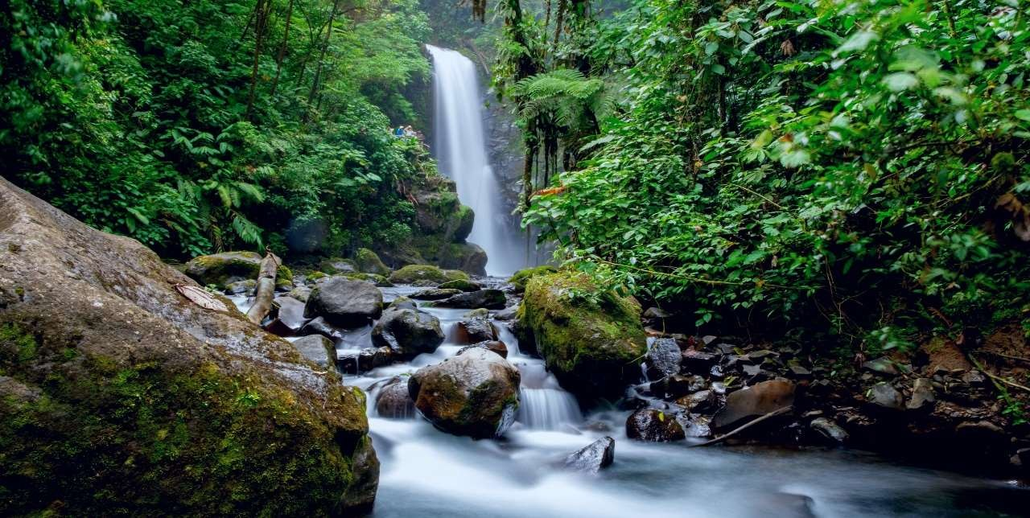

# Costa Rica

**2024**

# San José EXPRESS

**5 days / 4 nights**

4 nights in San José

## DAY 1. SAN JOSÉ

Arrival at Juan Santamaría International Airport in San José. Shuttle transfer to your hotel. Free time.

## DAY 2. SAN JOSÉ

Breakfast. An innovative and exciting city tour is waiting for you! We will take you to San José to witness the main historical landmarks of the city, which will create an interesting cultural experience for a better understanding of the evolution of Costa Rica. After visiting the Costa Rican capital, we are heading towards Ciudad Colón, where we will live an unforgettable experience at the Virilla Caves. This is an experience that will give us a clearer picture of the natural and architectural richness of Costa Rica. Free rest of the day. Lunch is included.

## DAY 3. SAN JOSÉ

Breakfast. Tour to the Volcán Poás National Park and La Paz Waterfall Gardens. Early in the morning we are heading to the Poás volcano. On the way there, you will be able to observe the different monuments and the famous “Parque de los Mangos”. Our first stop is at la Casita del Café, where we will receive a brief explanation about the fascinating history of coffee. Breathtaking nature and an impressive cloud forest welcome you as we arrive to our first main destination; the Volcán Poás National Park. You will be able to admire the volcano’s active crater as well as its incredible fumaroles. Later in the day, we are heading to La Paz Waterfall Garden, a natural park and wildlife refuge surrounded by jungle and amazing waterfalls. We will visit their butterfly and hummingbird garden and a feline rescue center. Free rest of the day.

## DAY 4. SAN JOSÉ

Breakfast. Free day to take any optional excursions or tours around the city.

## DAY 5. SAN JOSÉ

Breakfast. Transfer to Juan Santamaría International Airport. End of services.

**STARTING DATES**

Saturday, Sunday & Monday from January 10th till December 10th 2024. Easter time may have add-ons.

**PRICE INCLUDES**

* Private arrival and departure transfers to the airport
* 4 nights of accommodation in established hotels or similar
* Daily breakfast
* Regular transfers throughout the entire trip
* Trips according to program
* City Tour in San José
* Eco tour: Poás National Park and La Paz Waterfall Gardens
* Local Taxes

**ADDITIONAL INFORMATION**

* At least 2 passengers required to make the tours.
* The order of the trip may vary.



**ESTABLISHED HOTELS**

|  |  |  |
| --- | --- | --- |
|  |  | |
| **Superior Tourist Category** |  |
| **San José** | Hotel Auténtico [www.autenticohotel.com](http://www.autenticohotel.com/) | 4 nights |

|  |  |  |
| --- | --- | --- |
| **Deluxe Tourist** | | |
| **San José** | Hotel Wyndham Garden Escazú  [www.wyndhamhotels.com/es-xl/wyndham-garden/san-jose-costa-rica/wyndham-garden-san-jose-](http://www.wyndhamhotels.com/es-xl/wyndham-garden/san-jose-costa-rica/wyndham-garden-san-jose-) escazu/overview | 4 nights |

|  |  |  |
| --- | --- | --- |
| **Top Tourist** | | |
| **San José** | Hotel Barceló San José [www.barcelo.com/es-es/barcelo-san-](http://www.barcelo.com/es-es/barcelo-san-)  jose/?utm_source=google&utm_medium=organic&utm_campaign=my_business&utm_content=7290 | 4 nights |